**☺ 1 What is Git, GITHUB - Why do we need it?**

-> Git is a distributed VCS (version control system)

-> hosting services for git repositories are: 1) Bit bucket 2) GITLAB 3) GITHUB

-> .git folder have the history of whole project. It saves snapshots not the differences

-> Remote operations are operations performed in a network/internet. Ex: pulling a files, etc.

-> Remote repository: the repository present in a server (i.e. over the internet)

-> Commit is a process of saving the state of the changes made

-> Staging Area is the area where files are kept which need to be moved in the next commit. I.e. files to be committed are kept in staging area

-> It is good practice to stage the files which we want to commit

-> To add all the files in staging area we use

git add .

or

git add --a

-> git diff command compares working area to staging area

**☺ 2 Installing Git - Initial Setup**

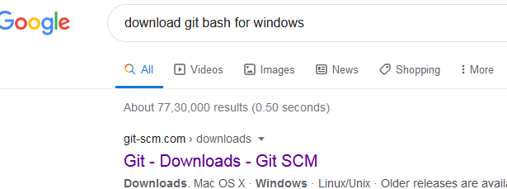

🡪Download and install it

**🡪**type the below commands in the gitbash terminal.

**1.**

lenovo@lenovo-PC MINGW32 ~

**$ git**

**2.**

lenovo@lenovo-PC MINGW32 ~

**$ pwd *(present working directory)***

/c/Users/lenovo

**3.**

lenovo@lenovo-PC MINGW32 ~

**$ cd desktop**

**lenovo@lenovo-PC MINGW32 ~/desktop**

$

**4.**

lenovo@lenovo-PC MINGW32 ~/desktop

**$ cd /c**

**lenovo@lenovo-PC MINGW32 /c**

**$**

🡪

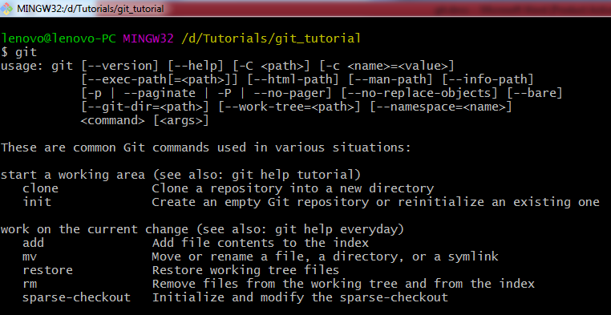

🡪

When we git for the first time we must Configure our username and email id in git

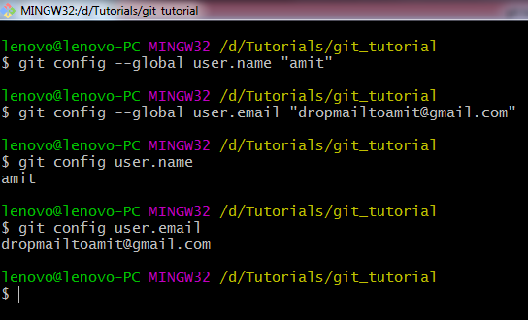

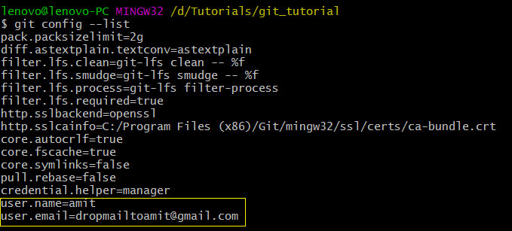

🡪Setting up editor in Linux

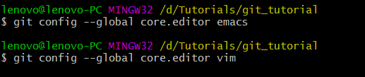

🡪Editing/deleting the configurations

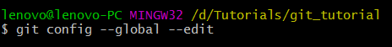

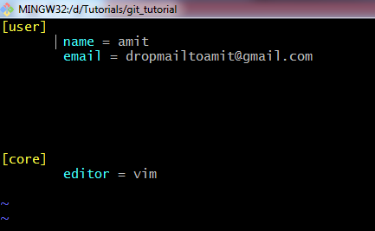

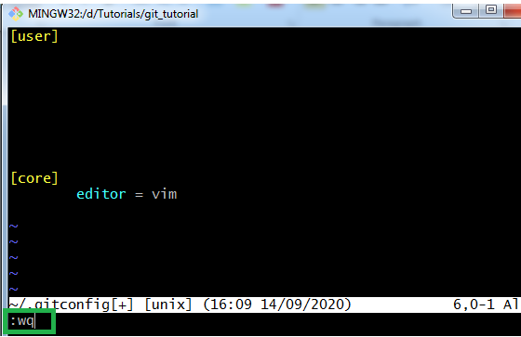

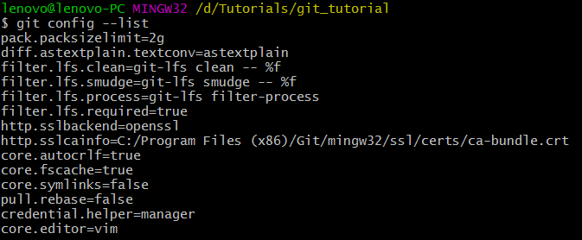

**☺3 Git-Three Stage Architecture**

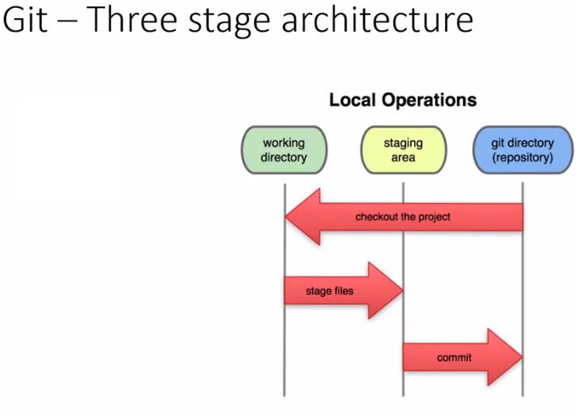

**☺4 Tracking Our first Git Project** 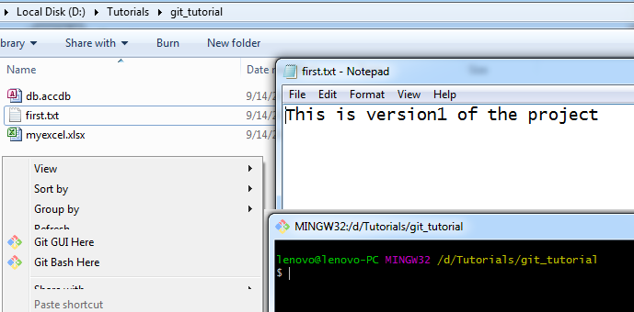

**🡪**

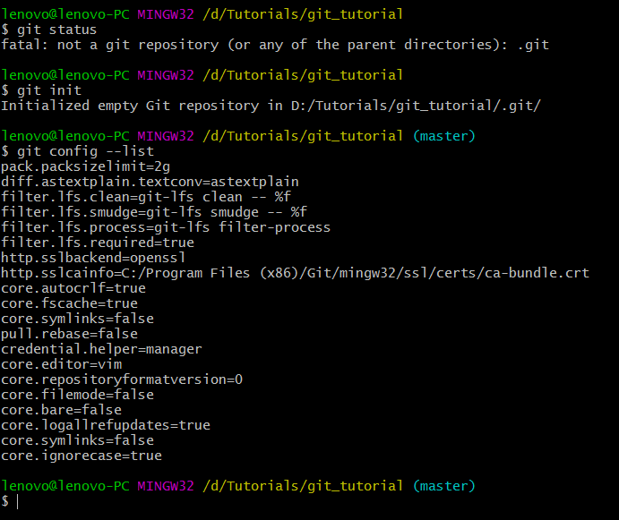

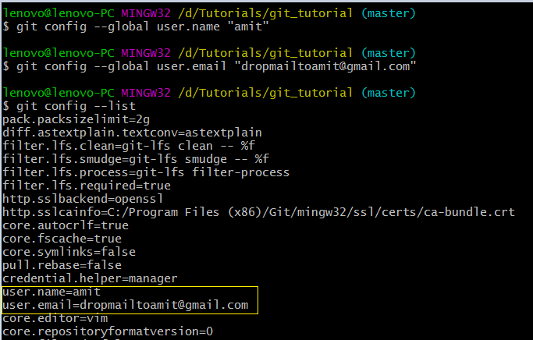

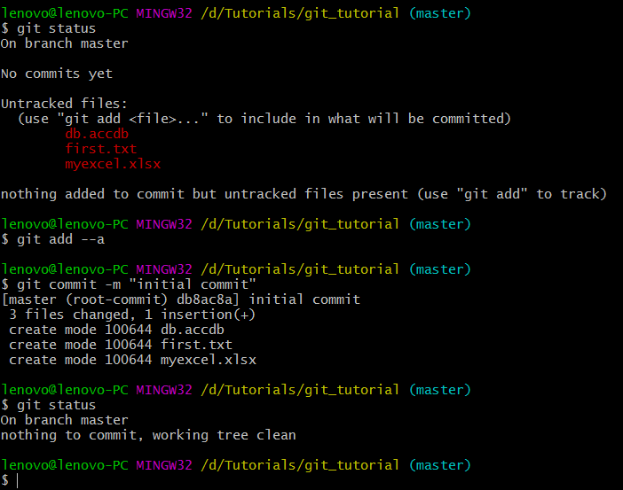

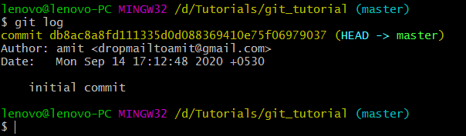

**git log commands** allows you to view information about previous commits that have occurred in a project

☺

🡪

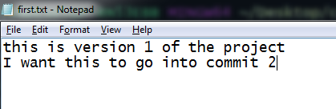

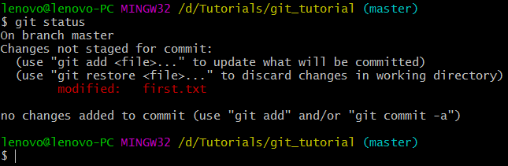

->Open the excel file and add some data into it

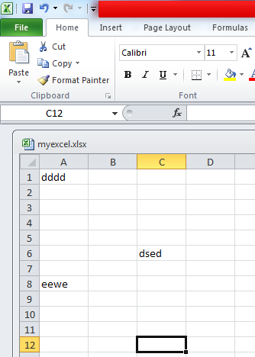

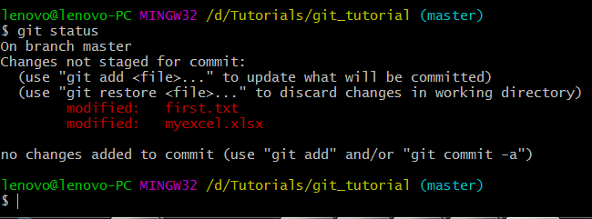

-- If you want to stage first.txt only then use the below command

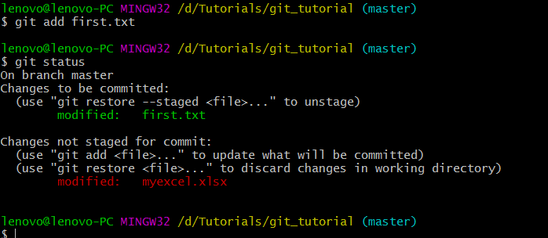

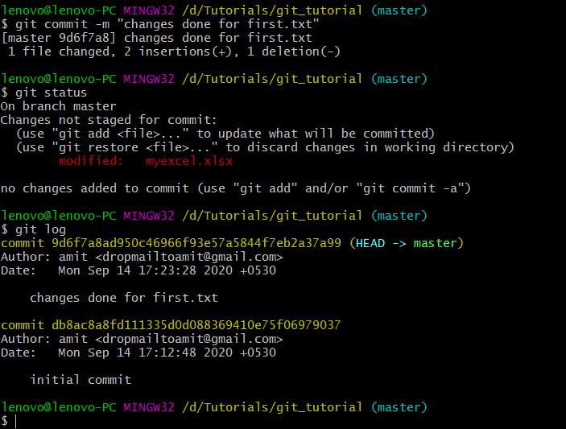

--.git folder have the history of whole project. If you want to delete the .git folder the use the below commands

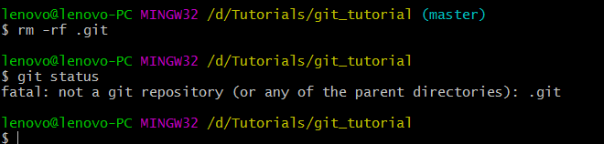

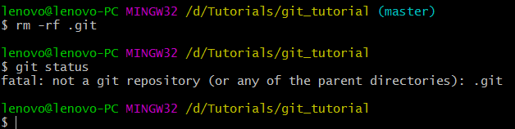

**☺5 Cloning a Remote Git Repository from GitHub**



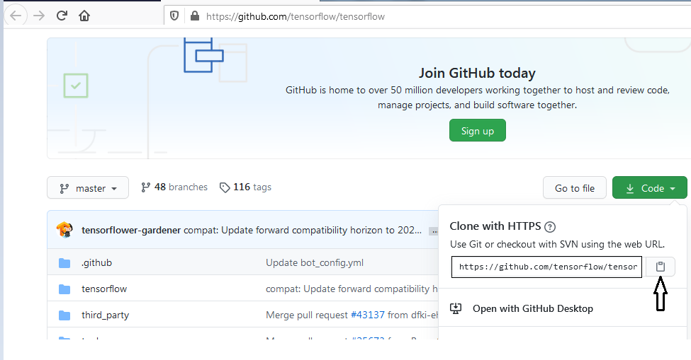

🡪

Linux Command

**$ pwd**

**$ ls**

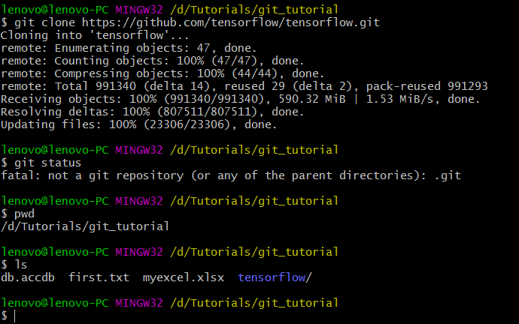

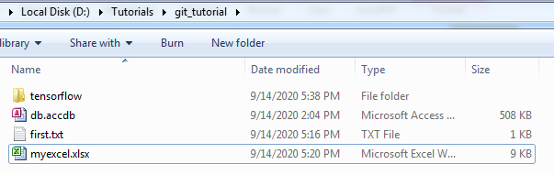

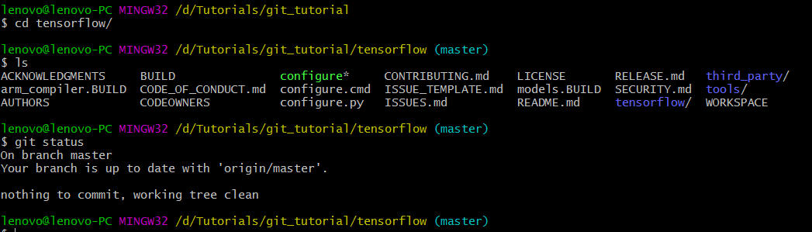

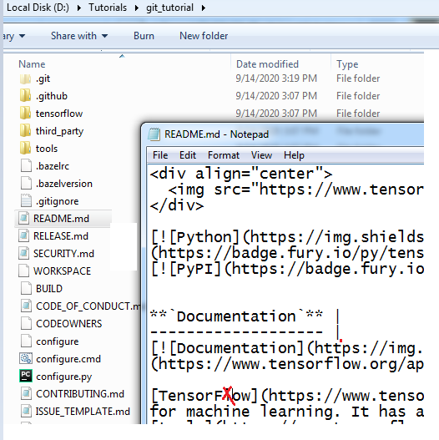

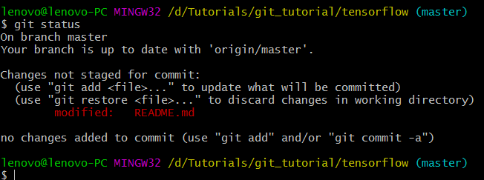

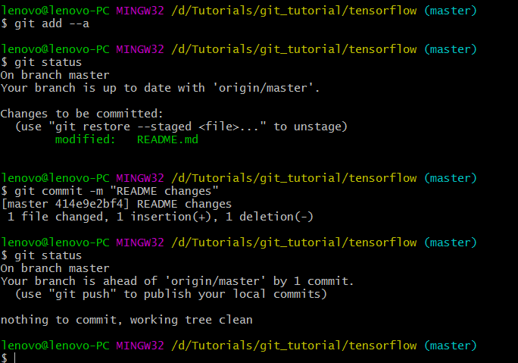

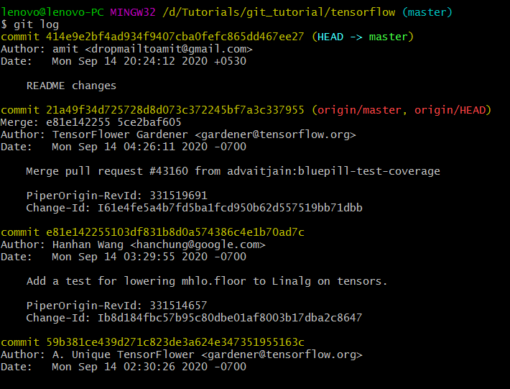

**☺6 Git File Status Lifecycle Git**

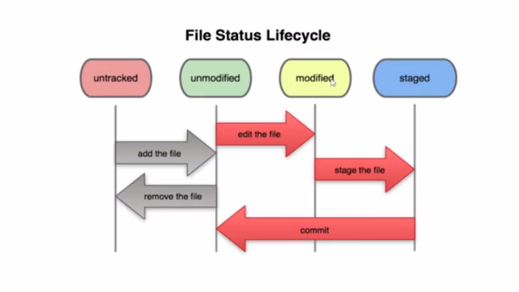

🡪

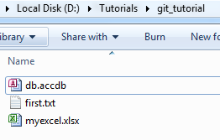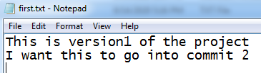

🡪**Untracked Stage** (the files are not being tracked by git)

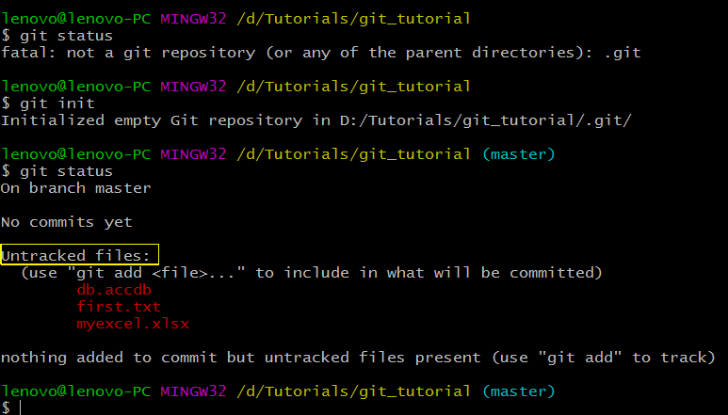

🡪**Unmodified Stage** (as we started to track the file for the first time by moving all the files to staging area. so we call it as unmodified stage)

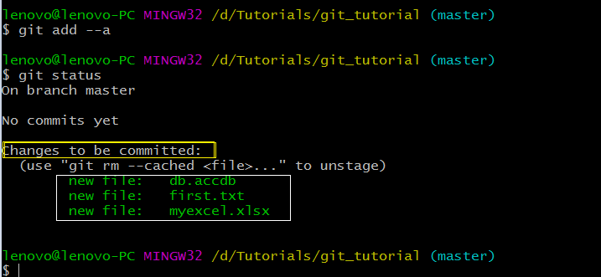

🡪



🡪modify first.txt

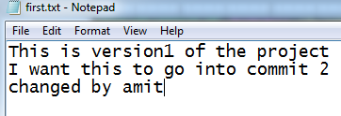

🡪unmodified and modified

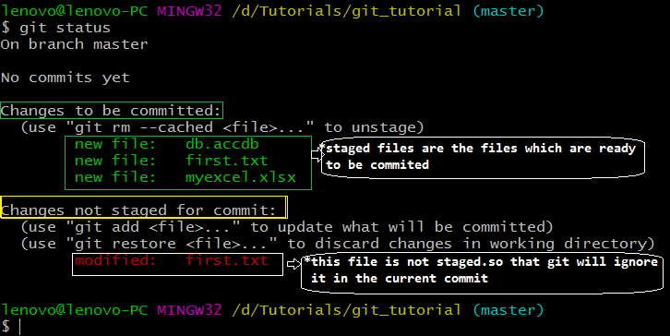

🡪Unmodified

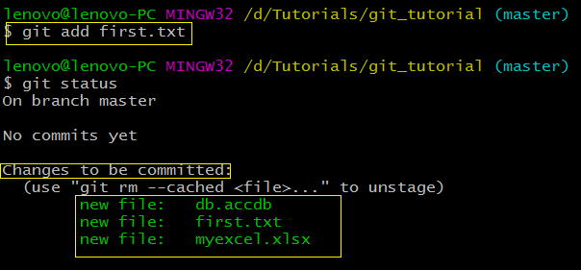

☺

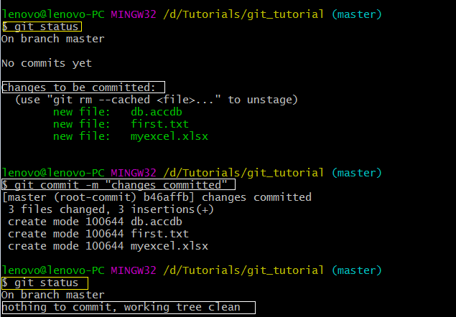

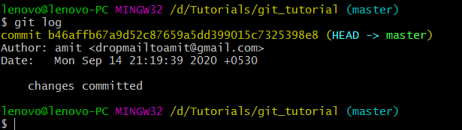

**☺7 .gitignore Ignoring Files in Git**

**Q. How to ignore file(s) in git so that it won’t come under untracked file(s)**

**🡪**

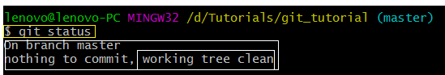

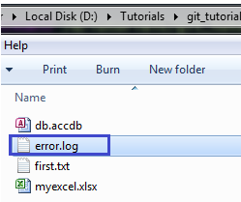

**🡪**modify error.log (we can consider this file as a log file which is not important to be committed )

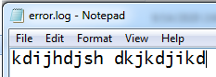

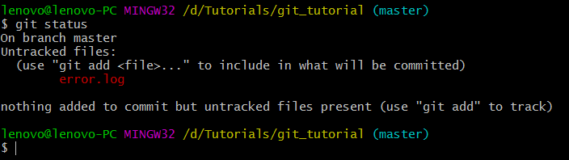

**🡪**



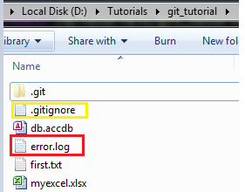

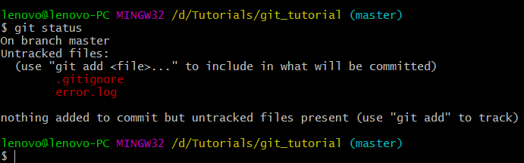

**🡪**

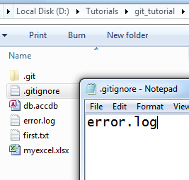

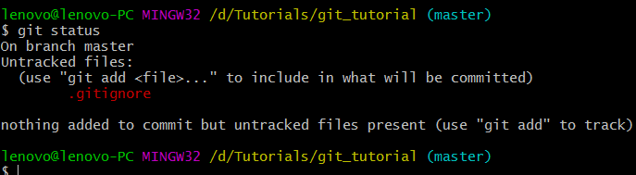

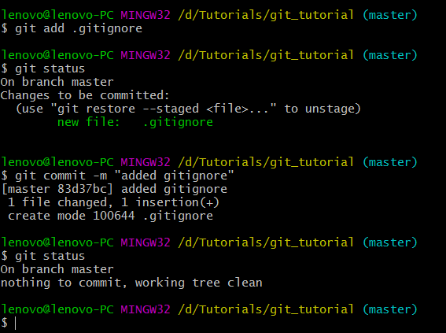

**🡪**Modify the error.log file

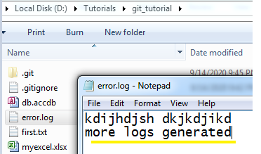

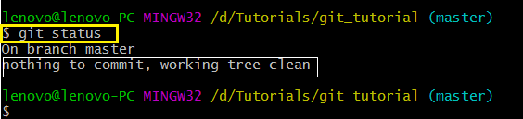

**☺**Suppose if multiple log files are generated and you want to ignore all of them then do the below: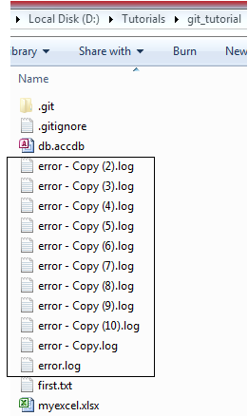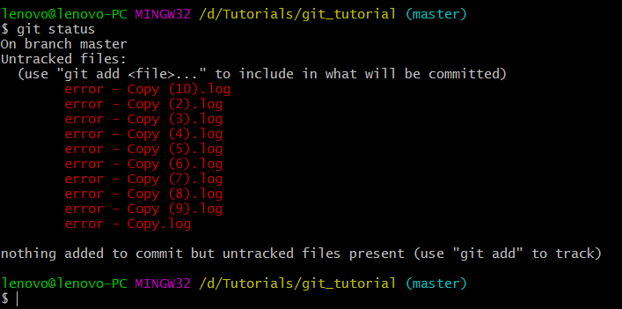

🡪

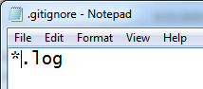

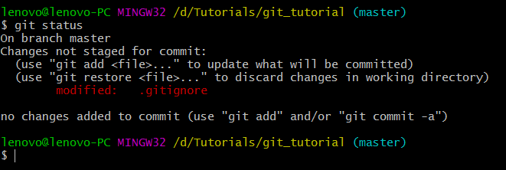

☺ Ignoring directory

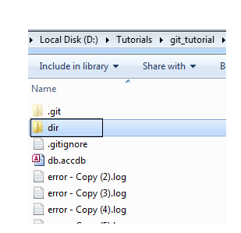

🡪By default git will ignore the empty directory (folder)

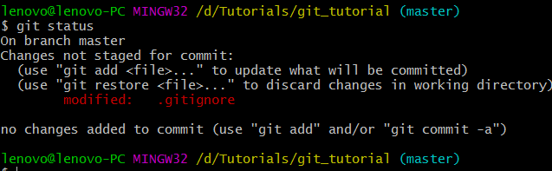

🡪Add few files to the dir folder

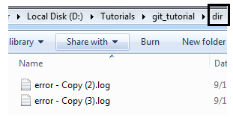

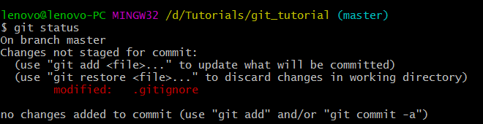

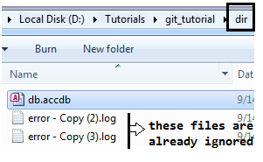

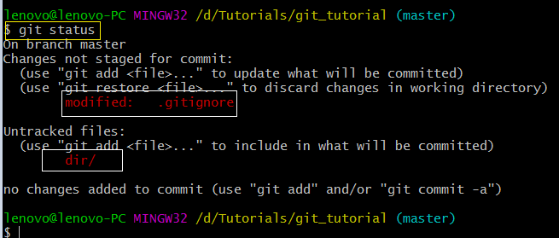

🡪Here we don’t want to track dir folder

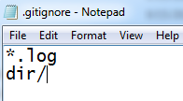

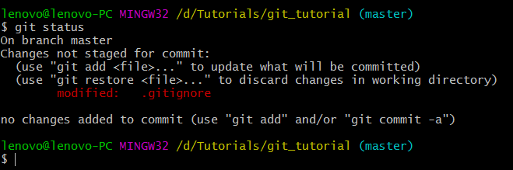

🡪

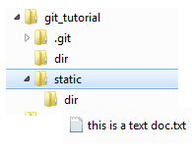

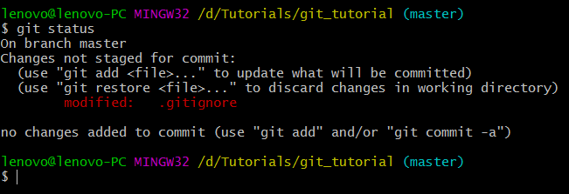

🡪

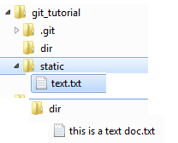

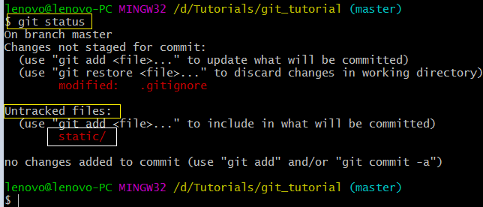

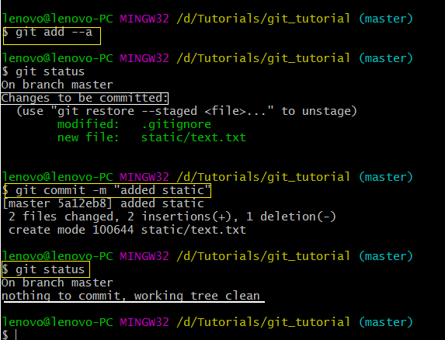

🡪

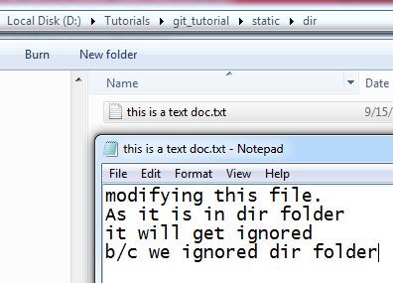

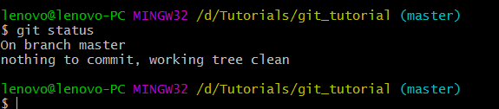

🡪

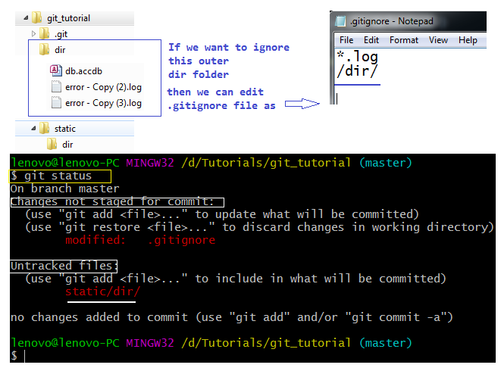

🡪

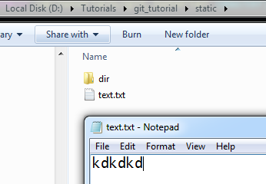

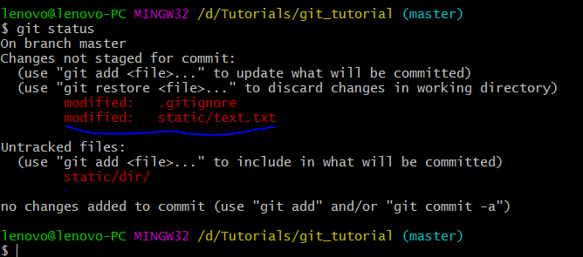

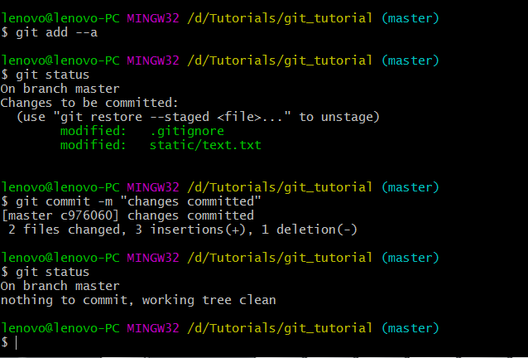

🡪

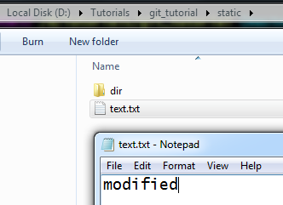

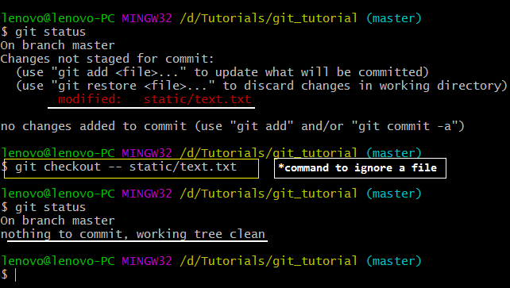

☺

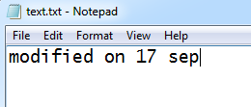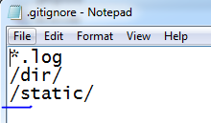

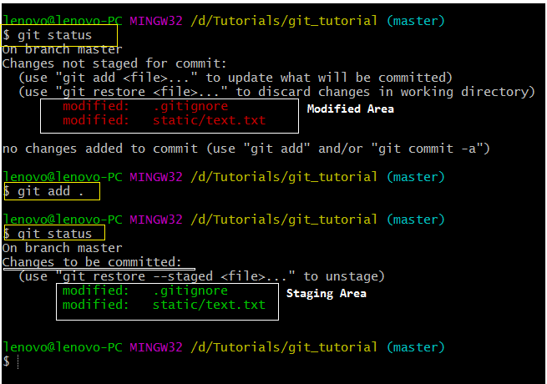

🡪

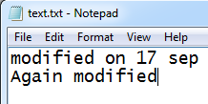

Now this file will be in both staging areas as well as in modified area (i.e. Working Area)

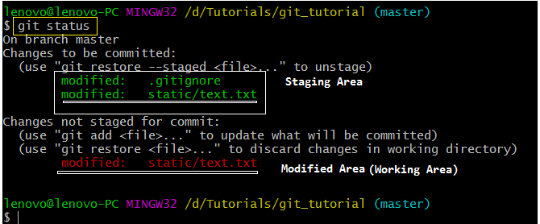

**☺8 Git Diff Showing Changes Between Commits Staging Area - Working Directory**

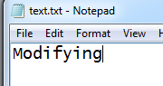 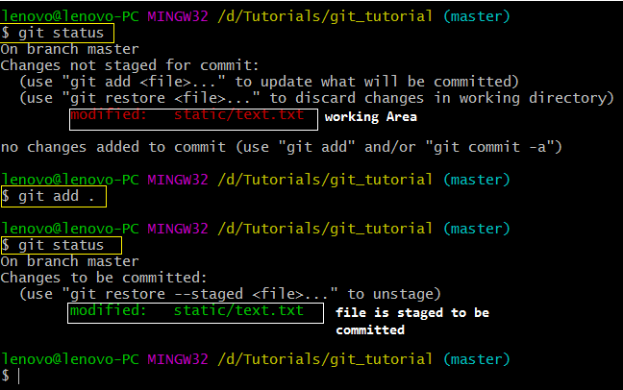

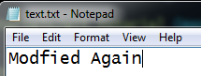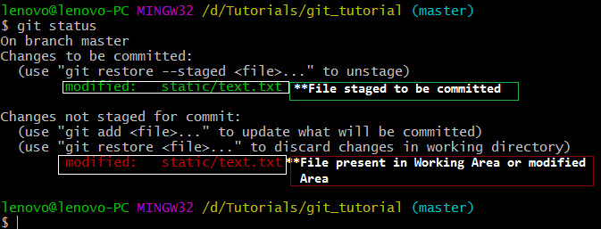

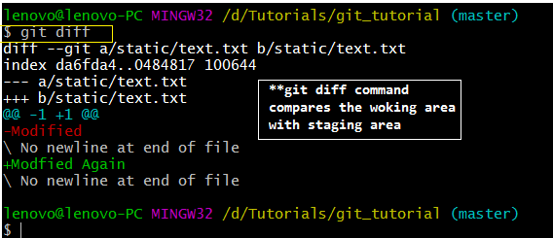

Q. What will happen when we add the modified file in staging area and run the git diff command again?

Answer:

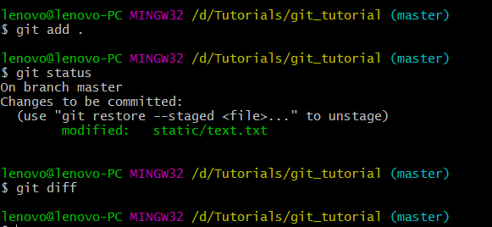

🡪 $ **git diff --staged**

Compares your previous commit with your current staging area

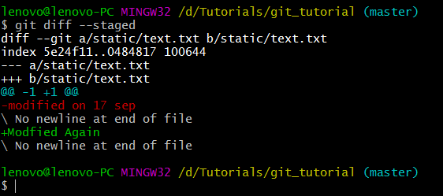

**☺9 Git- Skipping The Staging Area - Git Tutorials #9**

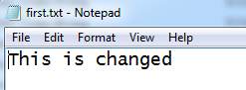

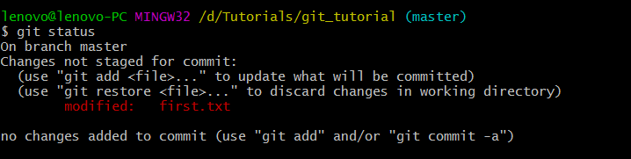

🡪

file added

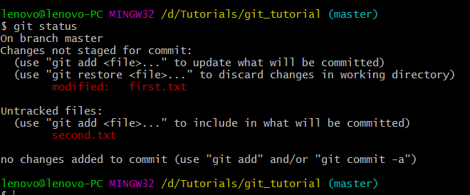



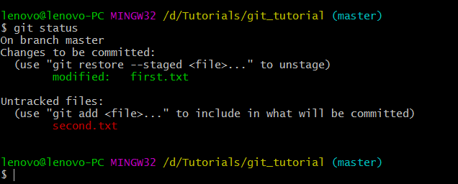

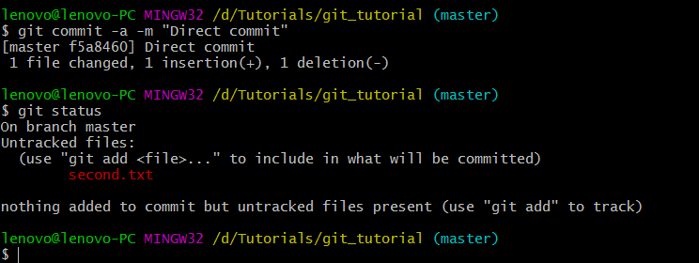

**🡪 $ git commit -a -m "Direct commit"**

Command adds the entire modified file in staging area and commits it. I.e. this command will stage the modified files and commit

The untracked file will not be committed

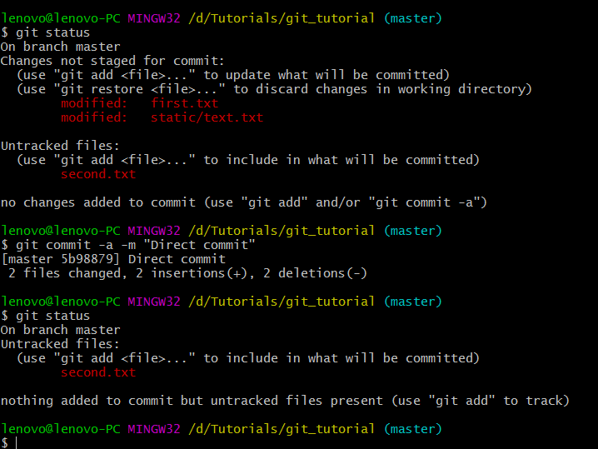

**☺10 Moving and Renaming Files In Git**

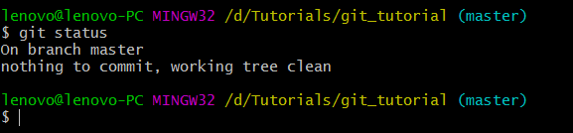

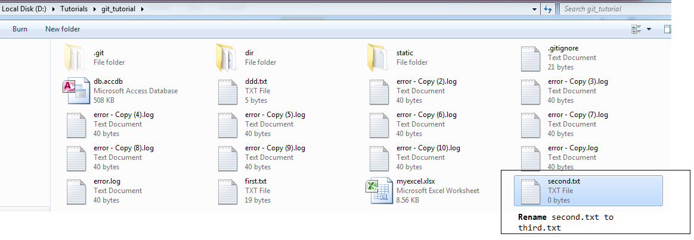

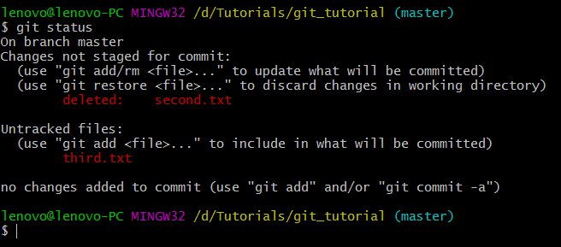

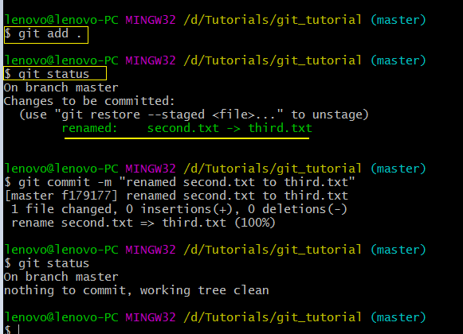

🡪

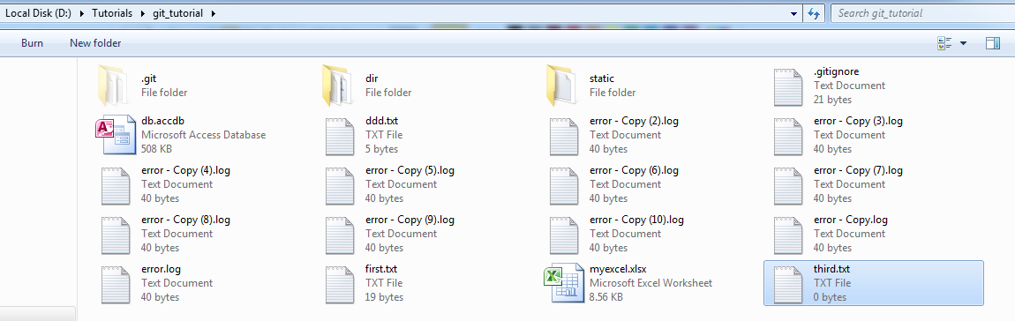

🡪

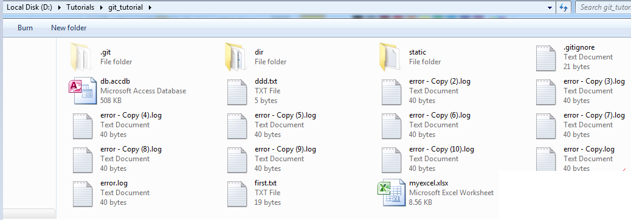

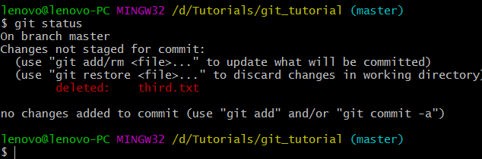

🡪

Ctrl+Z (retrieve your third.txt)

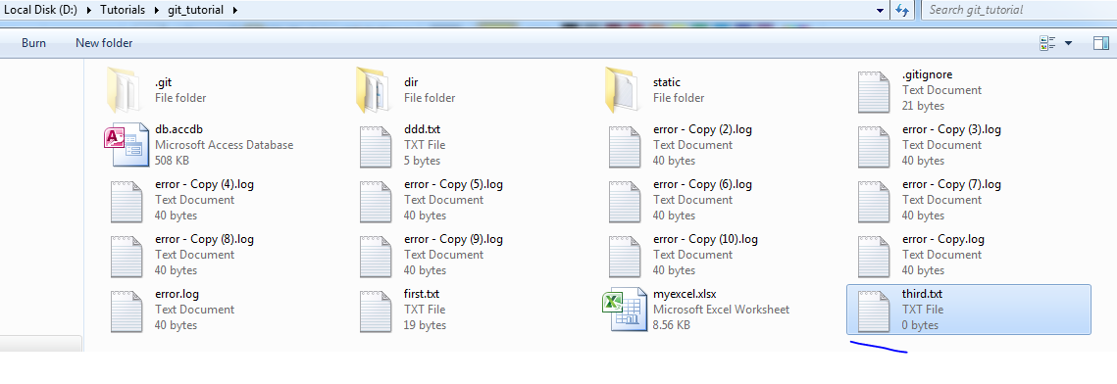

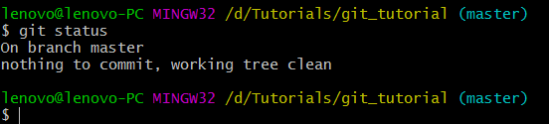

🡪Deleting from git command

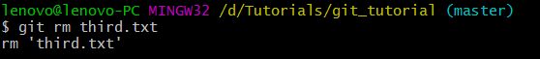

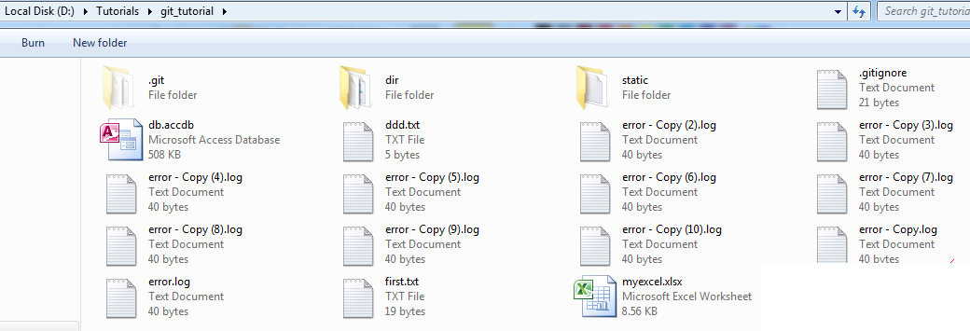

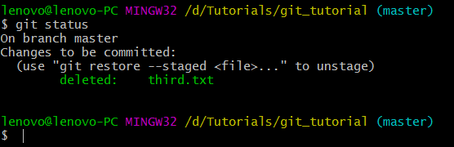

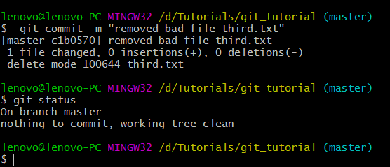

🡪Renaming a file using git command

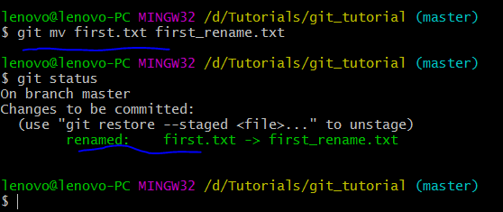

We have observed that when we use git command to rename or remove files it do the operations and staged the file also

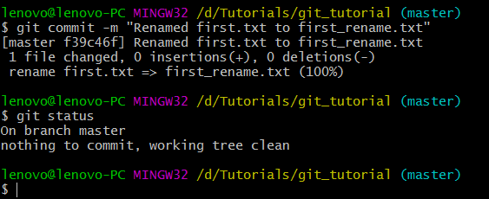

🡪

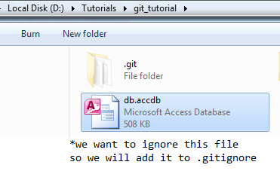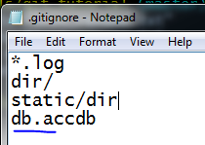

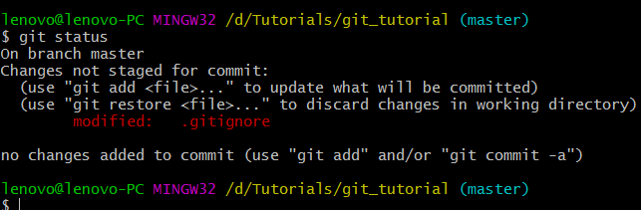

Edit db.accdb

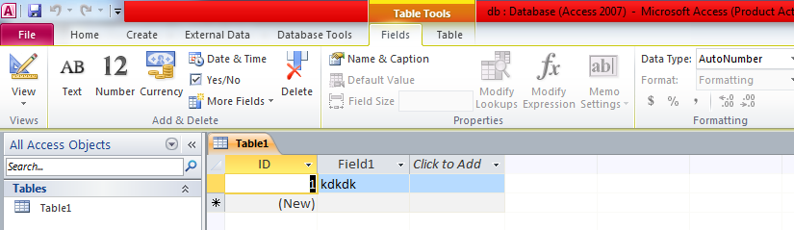

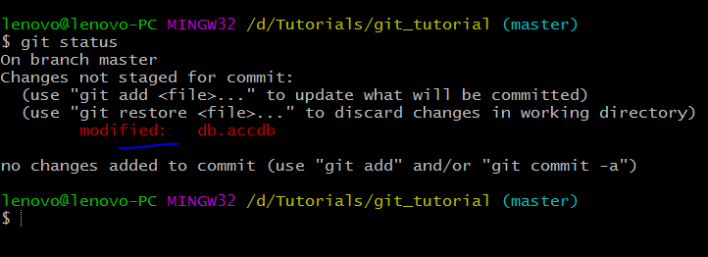

🡪If you will add the file which is being tracked earlier and later you want to untrack it. So, you add that file in .gitignore file (you need to tell git explicitly that you don’t want to track it by using the below command:

$ **git rm --cached** db.accdb)

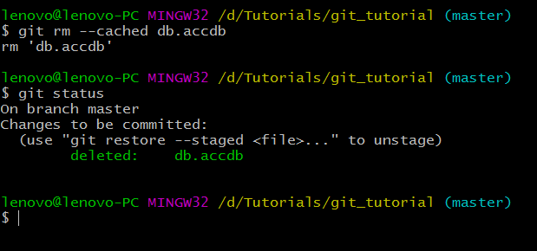

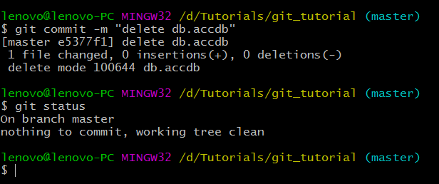

🡪Again Modifying db.accdb

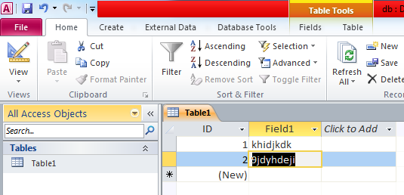

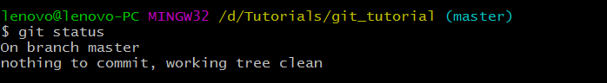Now git is not tracking db.accdb

☺**11 Git Log Viewing - Changing Commits In Git**

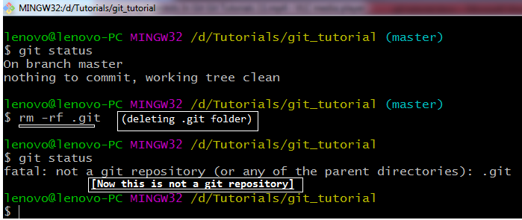

🡪



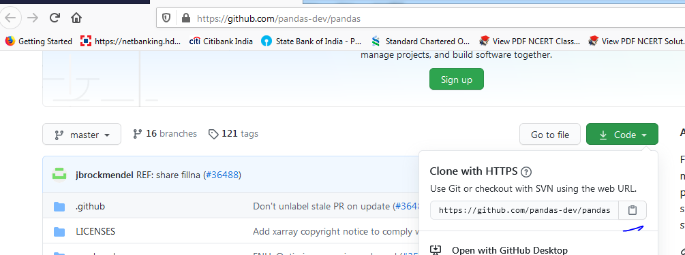

🡪

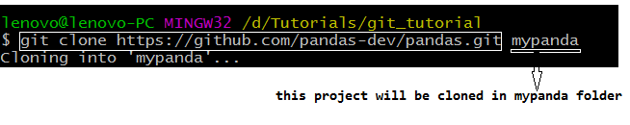

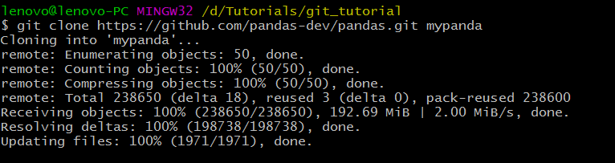

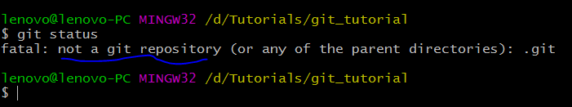

Here git_tutorial is not a git repository. Our git repository is mypanda folder

🡪

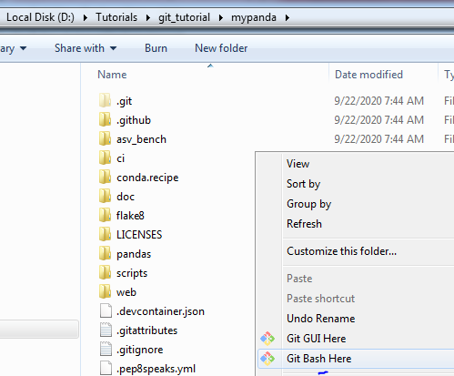

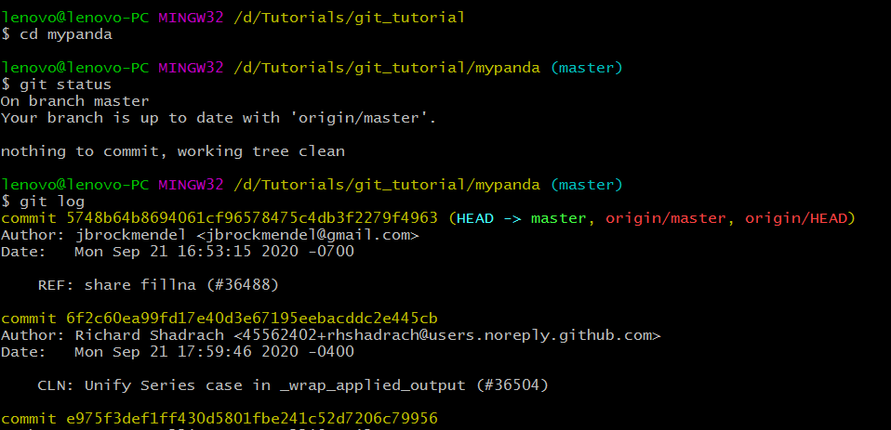

🡪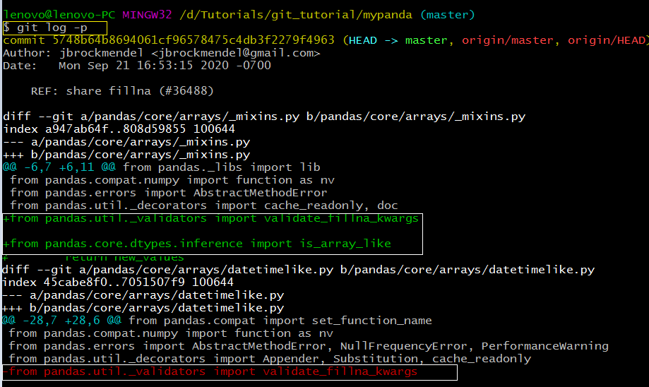

\***git log –p** command will show the commits with their differences (which code is added/deleted)

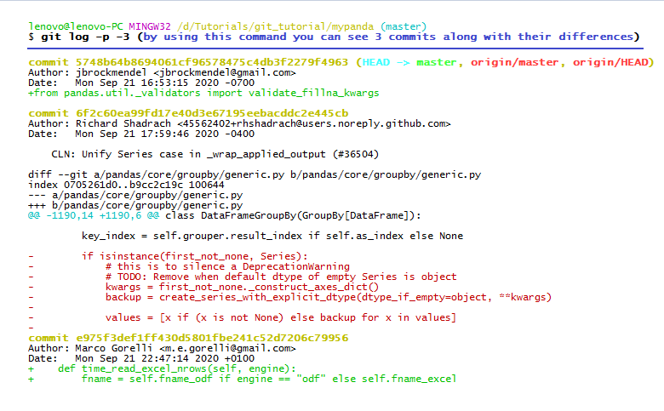

**🡪$ git log --stat** (shows the status of the commit in short form)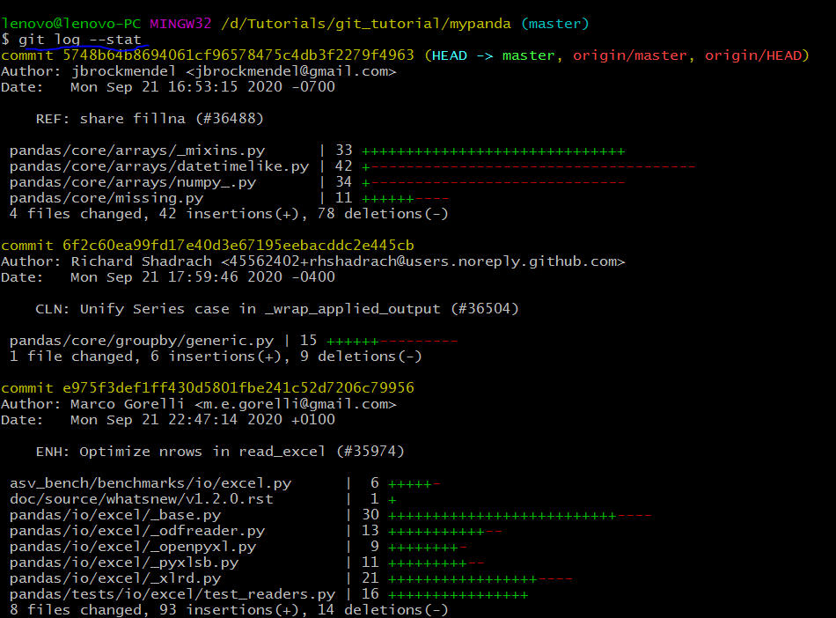

**🡪$ git log --pretty=oneline** (shows all the commits in one line)

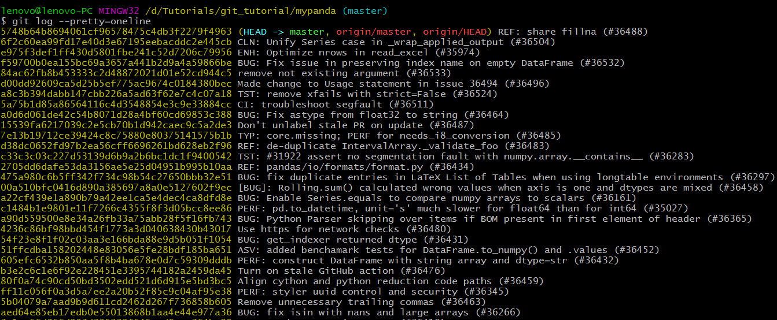

**🡪$ git log --pretty=short** (shows all the commits in short)

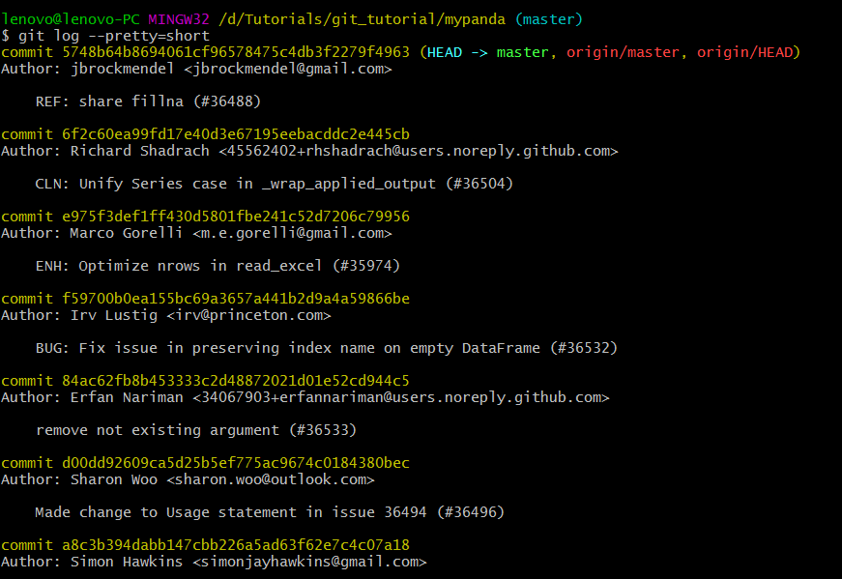

🡪

lenovo@lenovo-PC MINGW32 /d/Tutorials/git_tutorial/mypanda (master)

**$ git log --pretty=full**

commit 5748b64b8694061cf96578475c4db3f2279f4963 (HEAD -> master, origin/master, origin/HEAD)

Author: jbrockmendel <jbrockmendel@gmail.com>

Commit: GitHub <noreply@github.com>

REF: share fillna (#36488)

commit 6f2c60ea99fd17e40d3e67195eebacddc2e445cb

Author: Richard Shadrach <45562402+rhshadrach@users.noreply.github.com>

Commit: GitHub <noreply@github.com>

CLN: Unify Series case in _wrap_applied_output (#36504)

commit e975f3def1ff430d5801fbe241c52d7206c79956

Author: Marco Gorelli <m.e.gorelli@gmail.com>

Commit: GitHub <noreply@github.com>

ENH: Optimize nrows in read_excel (#35974)

commit f59700b0ea155bc69a3657a441b2d9a4a59866be

Author: Irv Lustig <irv@princeton.com>

Commit: GitHub <noreply@github.com>

BUG: Fix issue in preserving index name on empty DataFrame (#36532)

commit 84ac62fb8b453333c2d48872021d01e52cd944c5

Author: Erfan Nariman <34067903+erfannariman@users.noreply.github.com>

Commit: GitHub <noreply@github.com>

remove not existing argument (#36533)

commit d00dd92609ca5d25b5ef775ac9674c0184380bec

Author: Sharon Woo <sharon.woo@outlook.com>

Commit: GitHub <noreply@github.com>

Made change to Usage statement in issue 36494 (#36496)

commit a8c3b394dabb147cbb226a5ad63f62e7c4c07a18

Author: Simon Hawkins <simonjayhawkins@gmail.com>

Commit: GitHub <noreply@github.com>

:

🡪 commit a8c3b394dabb147cbb226a5ad63f62e7c4c07a18

**Author**: Simon Hawkins <simonjayhawkins@gmail.com>

**Commit**: GitHub <noreply@github.com>

**Author** is the person who created the file

**Commit**(er) is the person who has done changes in the file

🡪Apllying filters in git log

lenovo@lenovo-PC MINGW32 /d/Tutorials/git_tutorial/mypanda (master)

**$ git log --since=2.days** (**shows all the commits within 2 days**)

commit 5748b64b8694061cf96578475c4db3f2279f4963 (HEAD -> master, origin/master, origin/HEAD)

Author: jbrockmendel <jbrockmendel@gmail.com>

Date: Mon Sep 21 16:53:15 2020 -0700

REF: share fillna (#36488)

commit 6f2c60ea99fd17e40d3e67195eebacddc2e445cb

Author: Richard Shadrach <45562402+rhshadrach@users.noreply.github.com>

Date: Mon Sep 21 17:59:46 2020 -0400

CLN: Unify Series case in _wrap_applied_output (#36504)

commit e975f3def1ff430d5801fbe241c52d7206c79956

Author: Marco Gorelli <m.e.gorelli@gmail.com>

Date: Mon Sep 21 22:47:14 2020 +0100

ENH: Optimize nrows in read_excel (#35974)

commit f59700b0ea155bc69a3657a441b2d9a4a59866be

Author: Irv Lustig <irv@princeton.com>

Date: Mon Sep 21 17:42:48 2020 -0400

BUG: Fix issue in preserving index name on empty DataFrame (#36532)

commit 84ac62fb8b453333c2d48872021d01e52cd944c5

Author: Erfan Nariman <34067903+erfannariman@users.noreply.github.com>

Date: Mon Sep 21 23:24:08 2020 +0200

remove not existing argument (#36533)

commit d00dd92609ca5d25b5ef775ac9674c0184380bec

Author: Sharon Woo <sharon.woo@outlook.com>

Date: Tue Sep 22 05:11:46 2020 +0800

Made change to Usage statement in issue 36494 (#36496)

commit a8c3b394dabb147cbb226a5ad63f62e7c4c07a18

Author: Simon Hawkins <simonjayhawkins@gmail.com>

Date: Mon Sep 21 17:25:38 2020 +0100

:

**🡪 $ git log --since=2.weeks**

**$ git log --since=2.months**

**$ git log --since=2.years**

🡪

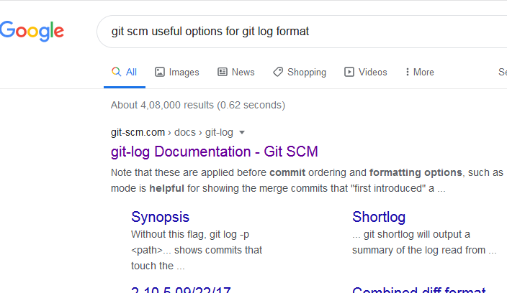

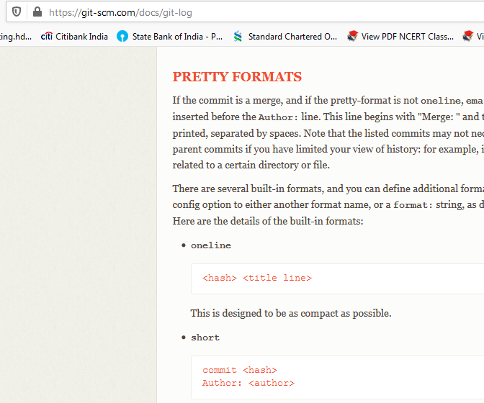

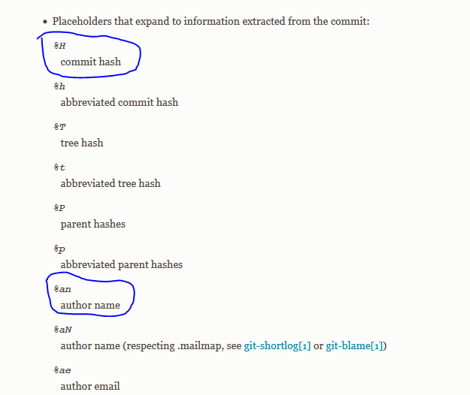

**🡪$ git log --pretty=format:"%h -- %an"**

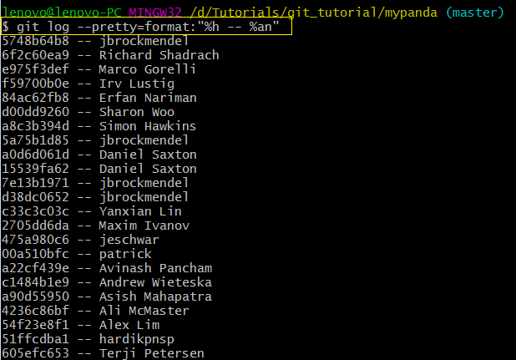

**🡪$ git log --pretty=format:"%h -- %ae"**

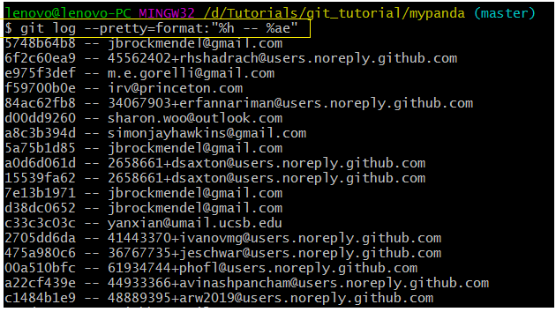

🡪

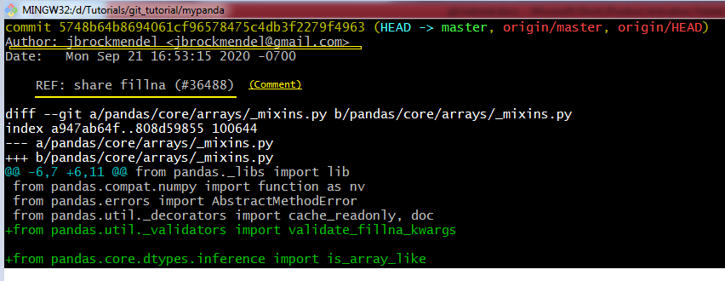

We want to modify a file and merge it to the above commit we also want to change the comment as well.

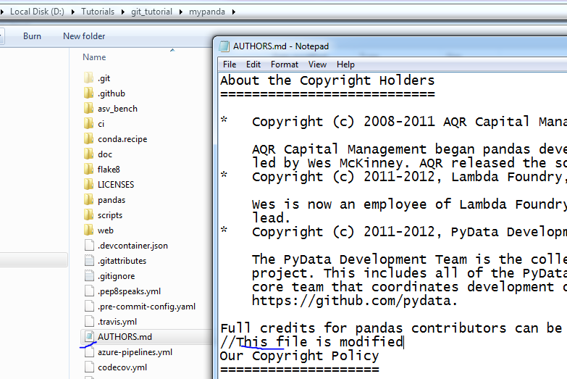

** We want to merge my changes (commit to Author: Author: jbrockmendel <jbrockmendel@gmail.com> and also want to edit his comment)

🡪

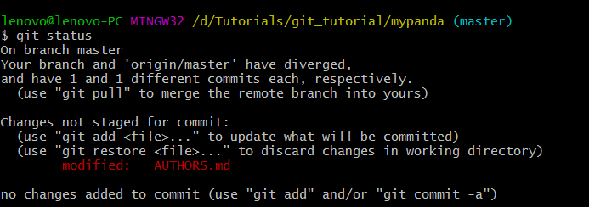

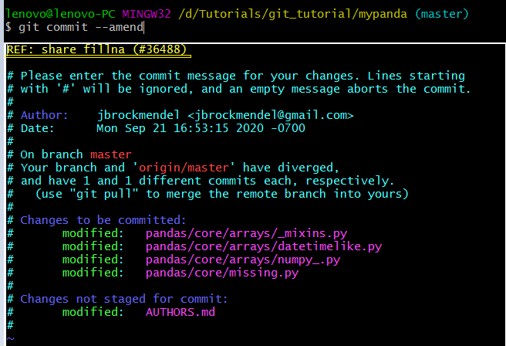

🡪Press Insert key to edit the above window (Vim Editor) -> then add you comment in the existing message

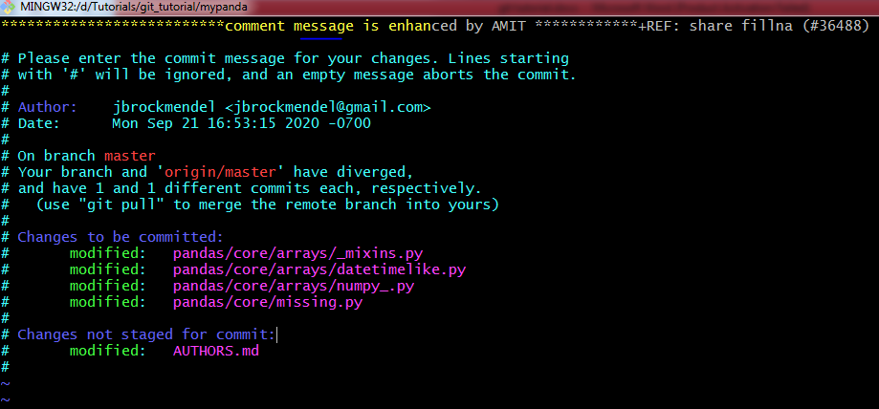

to save and exit the changed done in vim editor press **Esc** key and then type **:wq**

**:wq** (save and exit)

**:q** (exit)

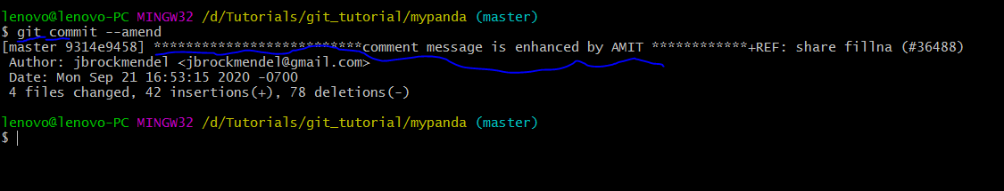

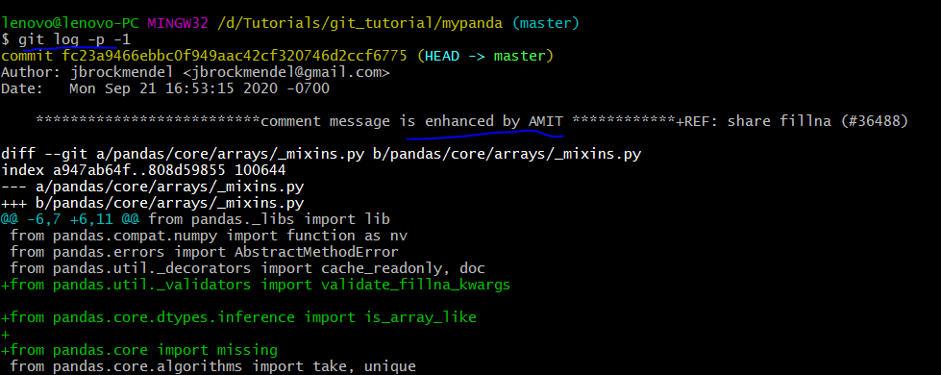



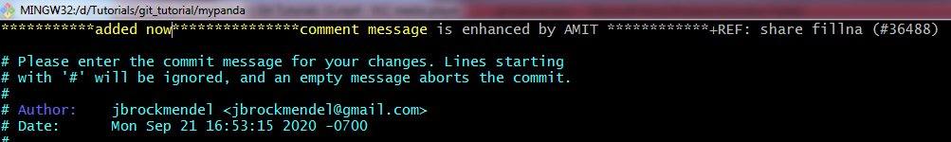

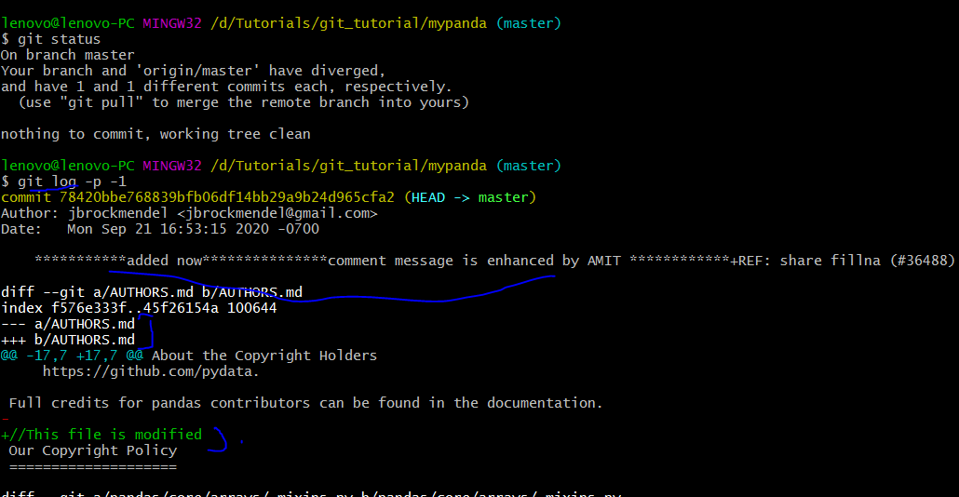

**☺ 12 Unstaging - Unmodifying Files In Git**

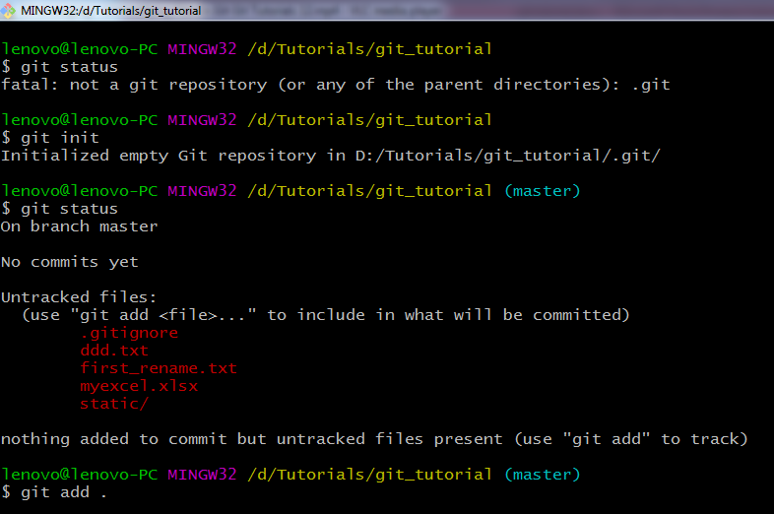

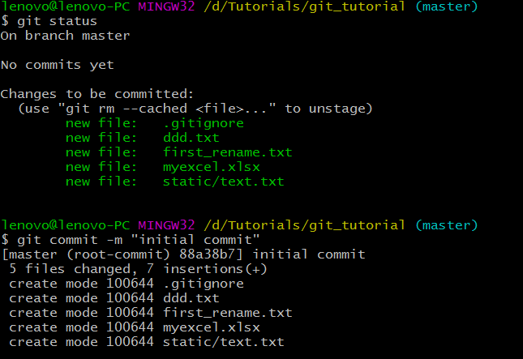

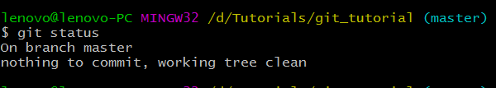

🡪Modify a file in your git repository and move that file in staging area

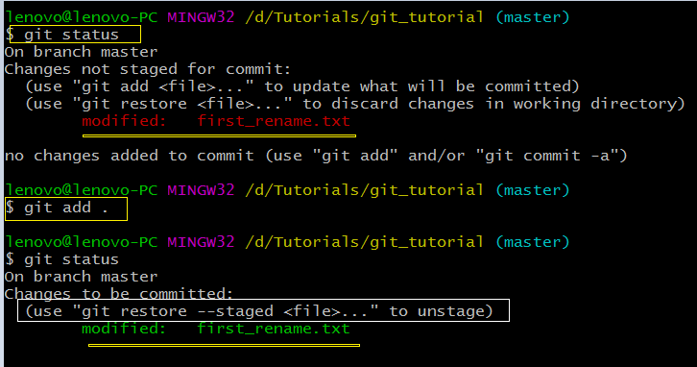

🡪Command to unstage the staged file

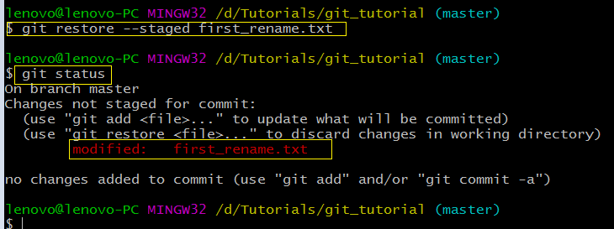

🡪 restoring a file to the previous commit.

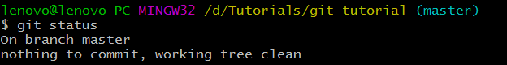

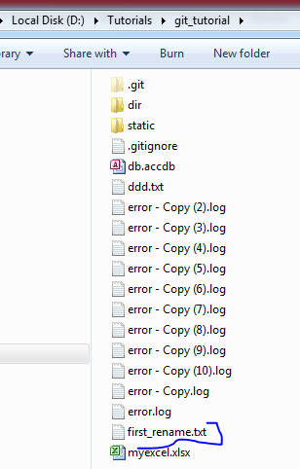

Modify **first_rename.txt**

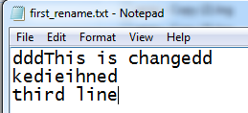

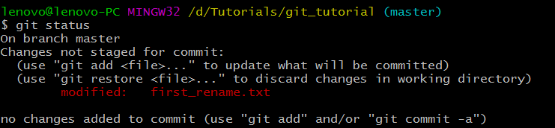

Suppose by mistake we have deleted the content or may be modified it mistakenly. So, we want to restore the file to the previous stage.

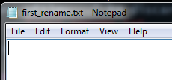

**$ git checkout -- first_rename.txt**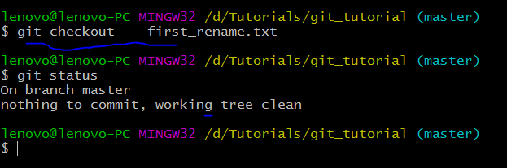

Our file is restored now ☺

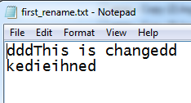

**🡪**

lenovo@lenovo-PC MINGW32 /d/Tutorials/git_tutorial (master)

**$ git status**

On branch master

Changes not staged for commit:

(use "git add <file>..." to update what will be committed)

(use "git restore <file>..." to discard changes in working directory)

**modified: ddd.txt**

**modified: first_rename.txt**

no changes added to commit (use "git add" and/or "git commit -a")

lenovo@lenovo-PC MINGW32 /d/Tutorials/git_tutorial (master)

**$ git add ddd.txt**

lenovo@lenovo-PC MINGW32 /d/Tutorials/git_tutorial (master)

**$ git status**

On branch master

Changes to be committed:

(use "git restore --staged <file>..." to unstage)

**modified: ddd.txt**

Changes not staged for commit:

(use "git add <file>..." to update what will be committed)

(use "git restore <file>..." to discard changes in working directory)

**modified: first_rename.txt**

lenovo@lenovo-PC MINGW32 /d/Tutorials/git_tutorial (master)

**$ git checkout -- first_rename.txt**

lenovo@lenovo-PC MINGW32 /d/Tutorials/git_tutorial (master)

**$ git status**

On branch master

Changes to be committed:

(use "git restore --staged <file>..." to unstage)

**modified: ddd.txt**

lenovo@lenovo-PC MINGW32 /d/Tutorials/git_tutorial (master)

**$ git commit -m "ddd.txt modified"**

[master d574542] ddd.txt modified

1 file changed, 1 insertion(+), 1 deletion(-)

lenovo@lenovo-PC MINGW32 /d/Tutorials/git_tutorial (master)

**$ git status**

On branch master

nothing to commit, working tree clean

lenovo@lenovo-PC MINGW32 /d/Tutorials/git_tutorial (master)

$

🡪

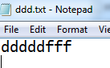 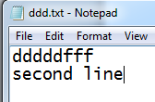

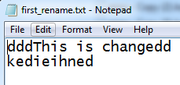 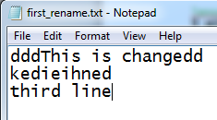

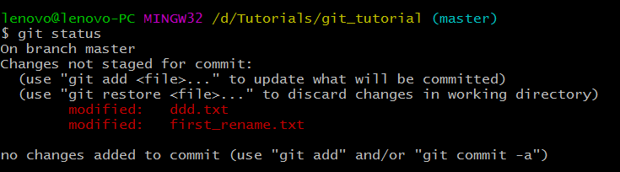

Command to restore all the modified files to the pervious commit

**$ git checkout -f**

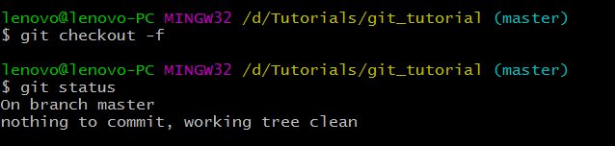



**☺ 13 GitHub Working with Remote Repositories**

🡪Create your GITHUB account



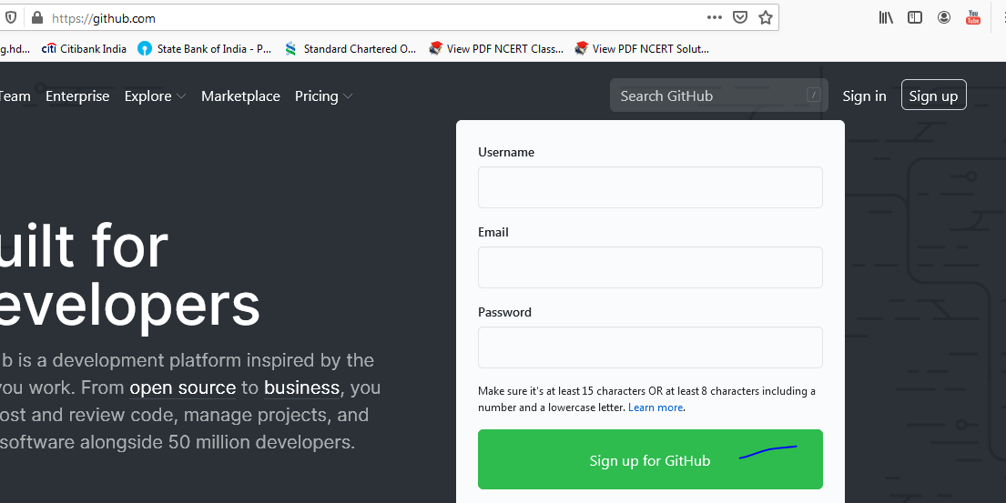

After creating the account

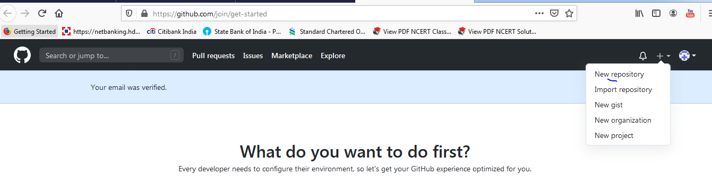

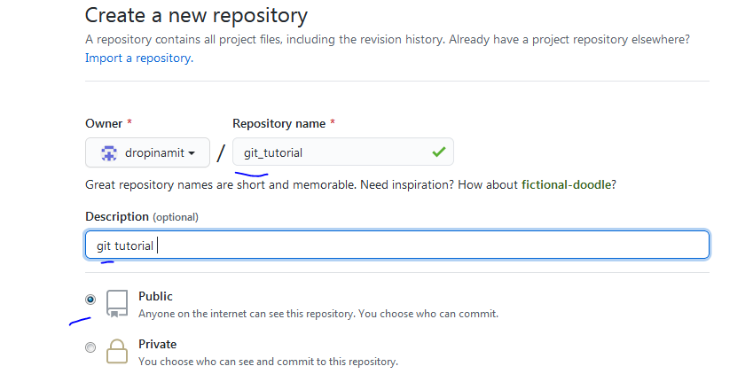

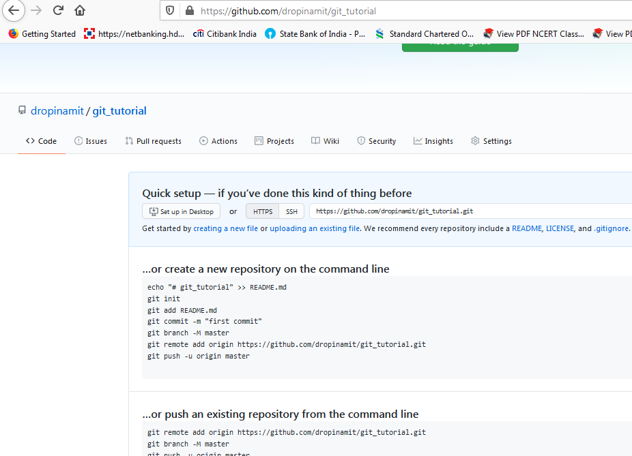

🡪**pull** – to pull the code to local (i.e. to your computer hard drive)

🡪**push** – to push the code into the repository

☺GITHUB is the website which is hosting GIT Repositories.

☺Remote means a website or a repository which is in web i.e. internet

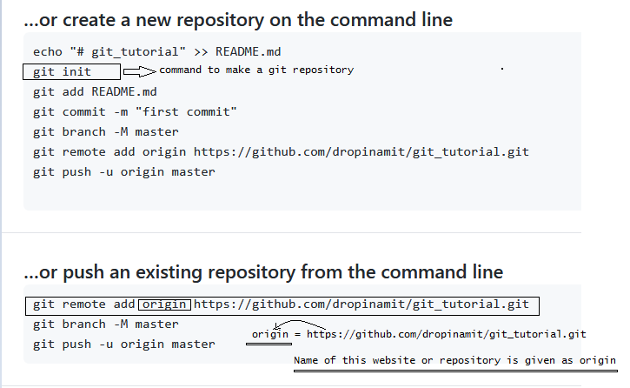

Here we have added a remote named origin which is having the git repository link

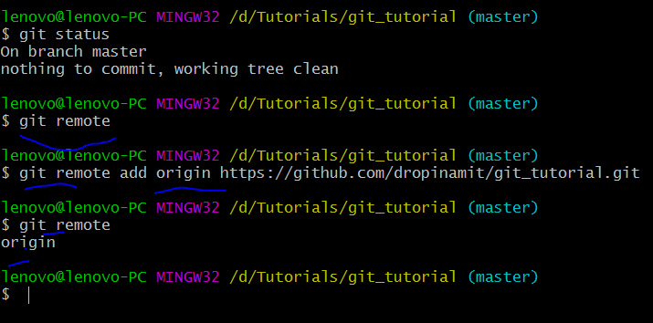

🡪git remote –v : shows the repository to pull and push

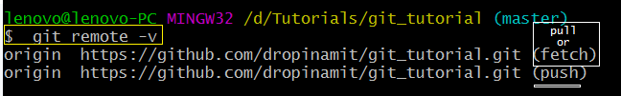

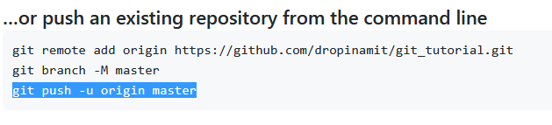

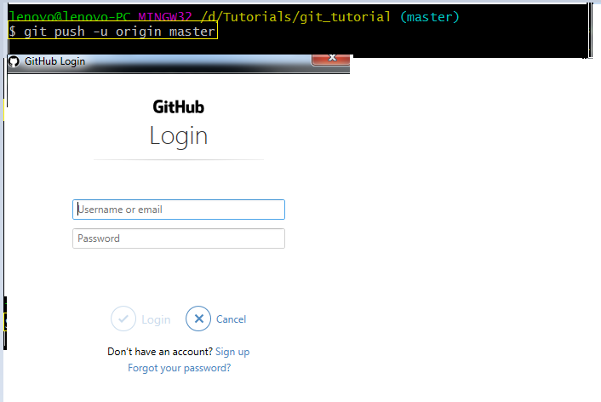

Fill in the credentials

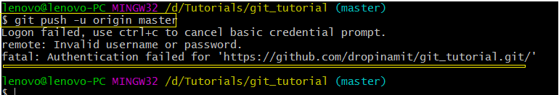

🡪How to get the permission to push?

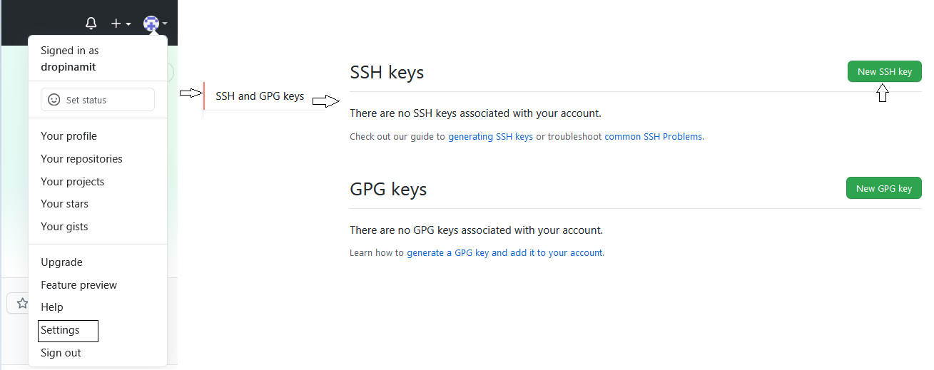

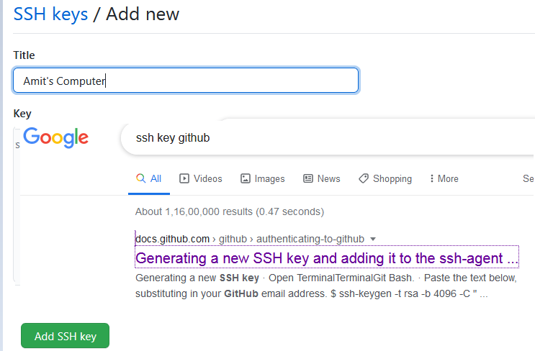

### [Generating a new SSH key](https://docs.github.com/en/github/authenticating-to-github/generating-a-new-ssh-key-and-adding-it-to-the-ssh-agent#generating-a-new-ssh-key)

1. Open Git Bash.
2. Paste the text below, substituting in your GitHub email address.

$ ssh-keygen -t rsa -b 4096 -C "your_email@example.com"

This creates a new ssh key, using the provided email as a label.

> Generating public/private rsa key pair.

1. When you're prompted to "Enter a file in which to save the key," press Enter. This accepts the default file location.

> Enter a file in which to save the key (/c/Users/you/.ssh/id_rsa):[Press enter]

1. At the prompt, type a secure passphrase. For more information, see ["Working with SSH key passphrases"](https://docs.github.com/en/articles/working-with-ssh-key-passphrases).
2. > Enter passphrase (empty for no passphrase): [Type a passphrase]

> Enter same passphrase again: [Type passphrase again]

🡪

lenovo@lenovo-PC MINGW32 /d/Tutorials/git_tutorial (master)

**$ ssh-keygen -t rsa -b 4096 -C "dropmailtoamit@gmail.com"**

Generating public/private rsa key pair.

Enter file in which to save the key (/c/Users/lenovo/.ssh/id_rsa): **<-|**

Created directory '/c/Users/lenovo/.ssh'.

Enter passphrase (empty for no passphrase): **<-|**

Enter same passphrase again: <-|

Your identification has been saved in /c/Users/lenovo/.ssh/id_rsa

Your public key has been saved in /c/Users/lenovo/.ssh/id_rsa.pub

The key fingerprint is:

SHA256:eUa07w0wJ6rOiJbqVSEFk19anDR8D3iIk2yWRs+6gDg dropmailtoamit@gmail.com

The key's randomart image is:

+---[RSA 4096]----+

| o=oBo+ . |

| .oXoO.= . |

| .=.=oo O . |

|. . .oo + B |

|E. . o S o o |

| . o .. o . o |

| o .. . . |

| +. + |

|o+. . o |

+----[SHA256]-----+

🡪

lenovo@lenovo-PC MINGW32 /d/Tutorials/git_tutorial (master)

**$ eval $(ssh-agent -s)**

Agent pid 735

🡪

lenovo@lenovo-PC MINGW32 /d/Tutorials/git_tutorial (master)

**$ ssh-add ~/.ssh/id_rsa**

Identity added: /c/Users/lenovo/.ssh/id_rsa (dropmailtoamit@gmail.com)

🡪

lenovo@lenovo-PC MINGW32 /d/Tutorials/git_tutorial (master)

**$ tail ~/.ssh/id_rsa.pub**

ssh-rsa  dropmailtoamit@gmail.com

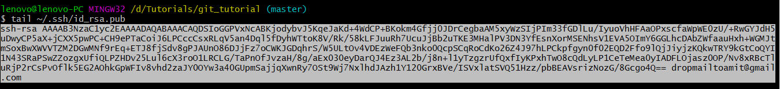

Copy it and paste it

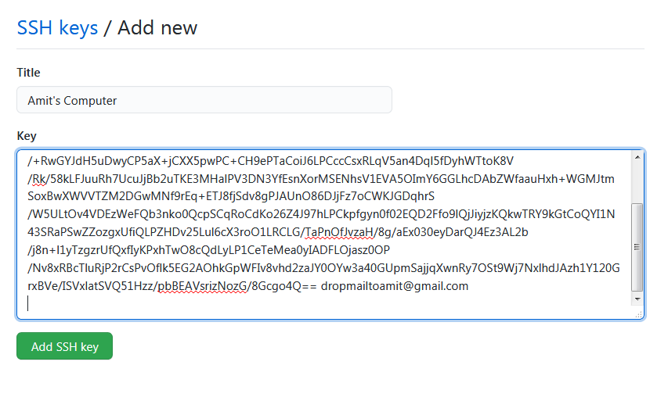

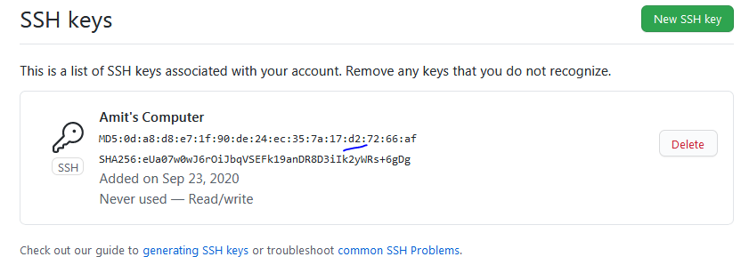

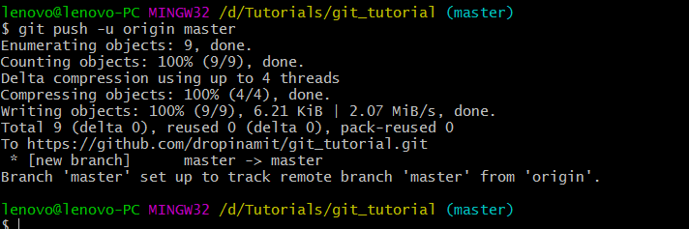

🡪go to your GITHUB and check the push you’ve committed

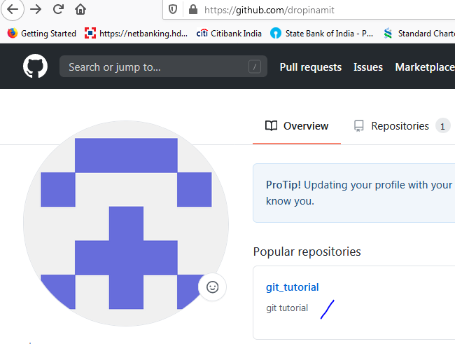

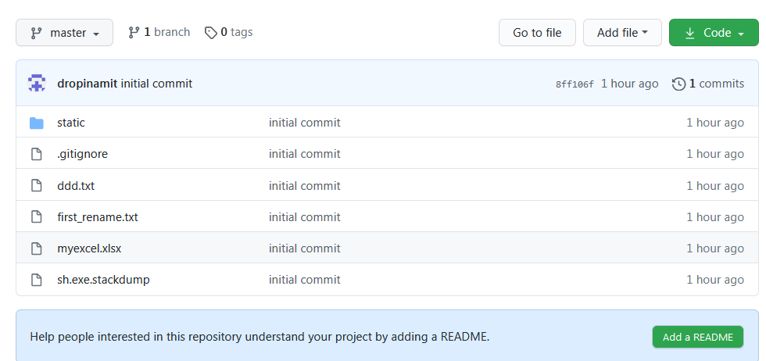

🡪

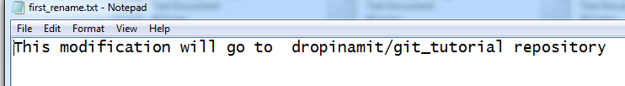

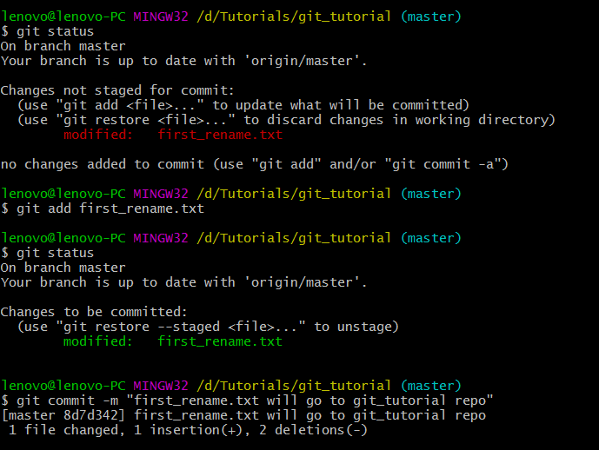

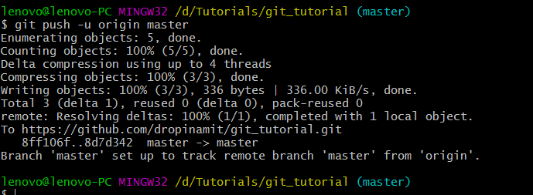

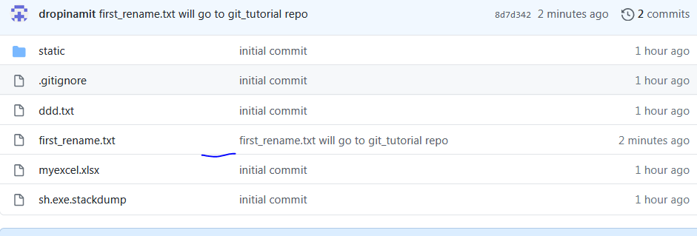

**☺14 Setting Alias In Git**

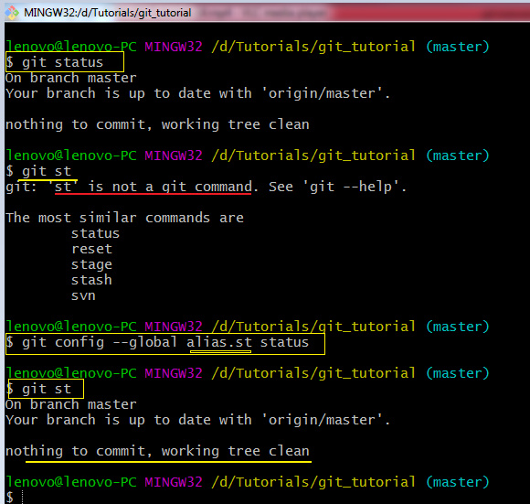

🡪Editing / Deleting the configuration.

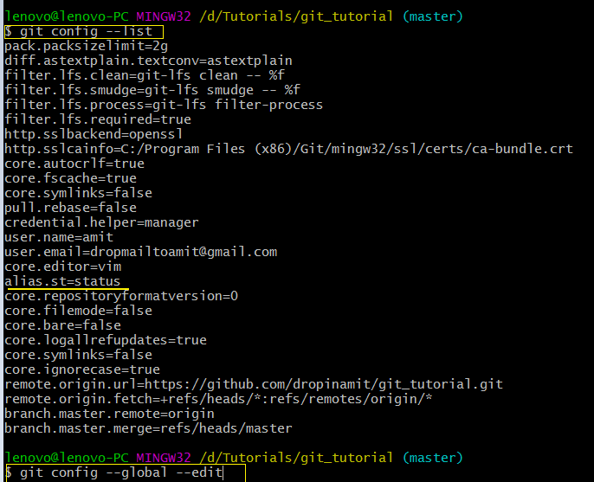

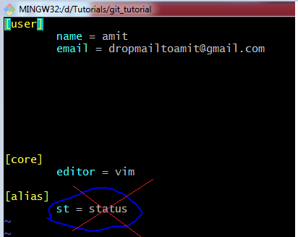

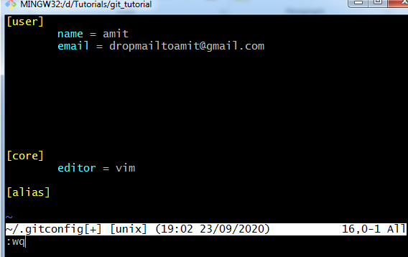

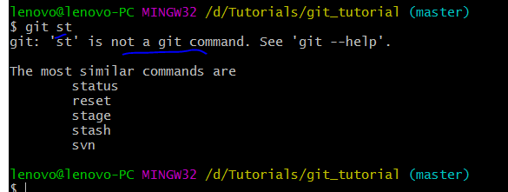

**☺15 Git Creating - Switching Branches In Git**

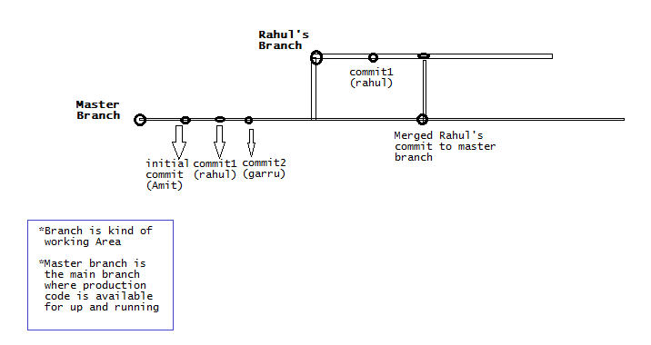

**🡪** Create this.txt

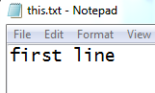

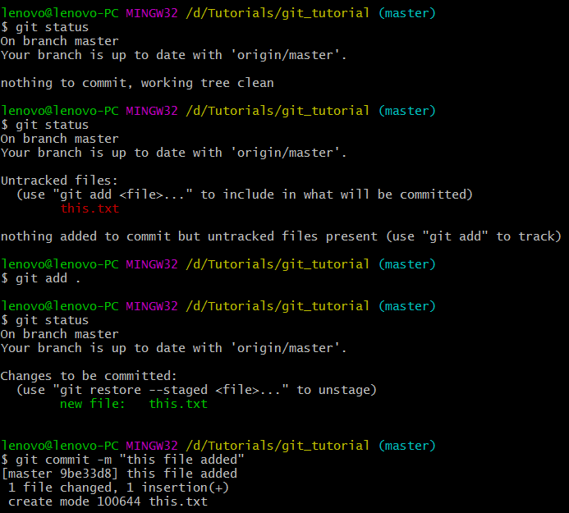

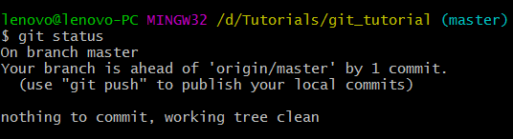

🡪

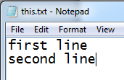

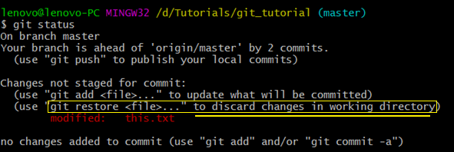

**$ git restore this.txt**

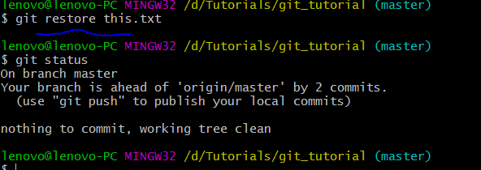



🡪Creating a new branch and switching to that branch

lenovo@lenovo-PC MINGW32 /d/Tutorials/git_tutorial (master)

**$ git checkout -b** amit_develop(creates new branch and switch to the created branch)

Switched to a new branch 'amit_develop'

**lenovo@lenovo-PC MINGW32 /d/Tutorials/git_tutorial (amit_develop)**

$

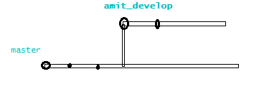

🡪

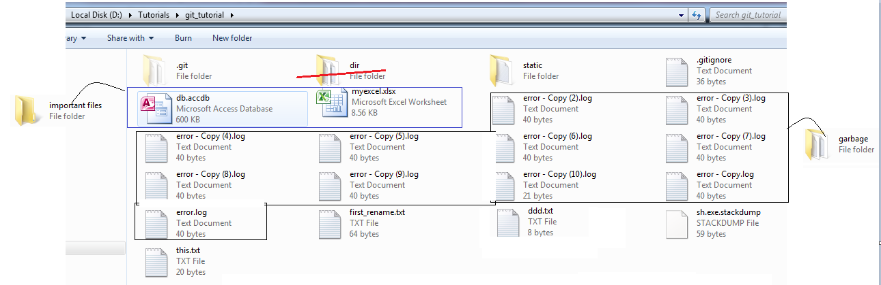

🡪

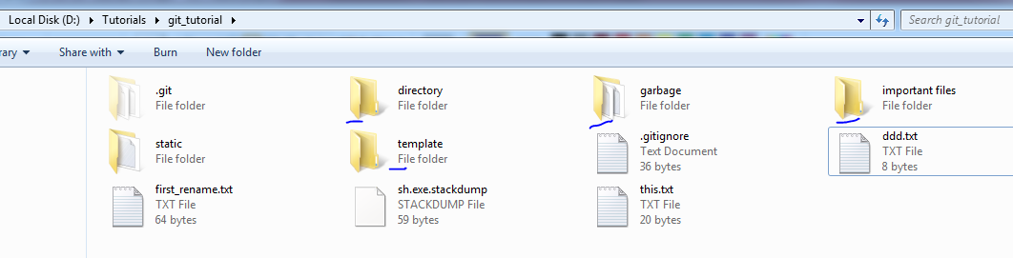

🡪

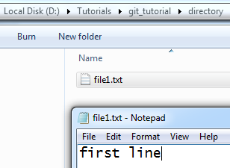

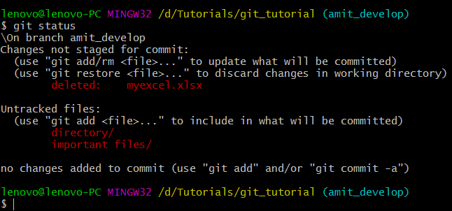

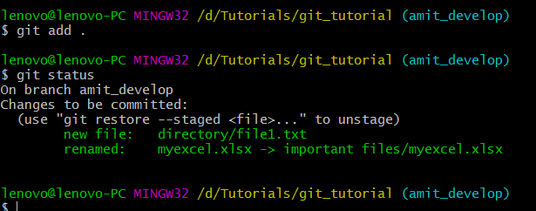 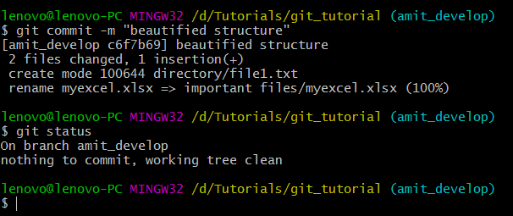

🡪when we are switching to master branch from amit_develop branch we will get back to the previous stage or the stage in which master branch is in.

🡪Currently we are in amit_develop branch

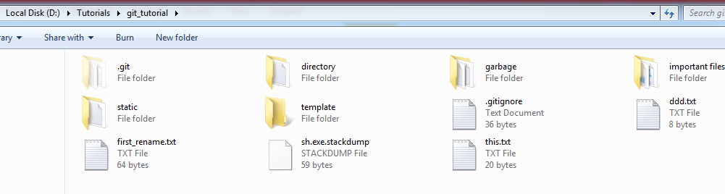

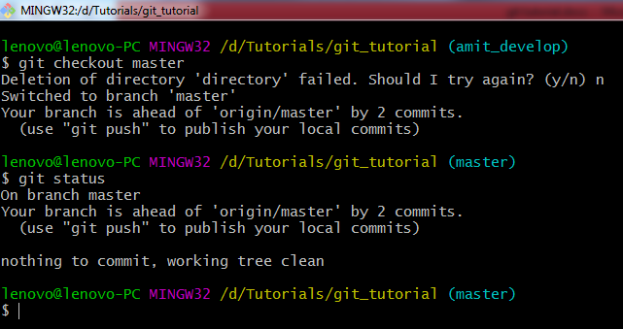

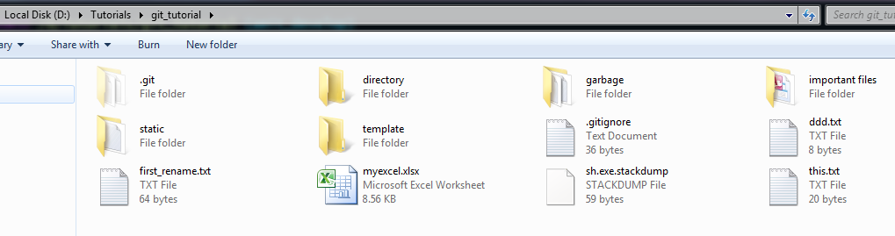

🡪

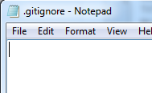

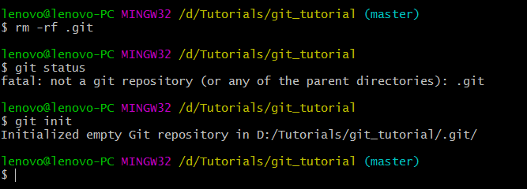 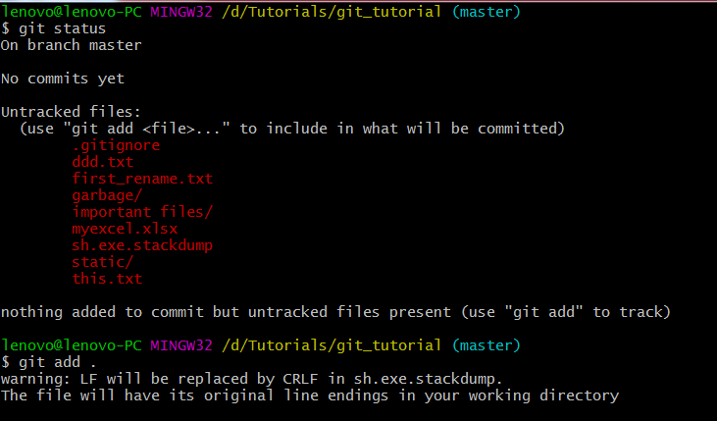

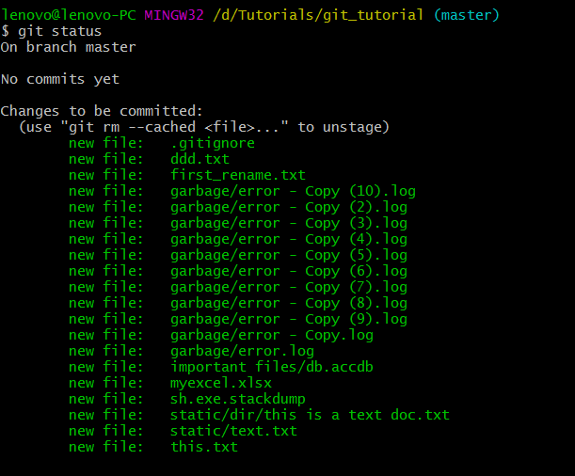

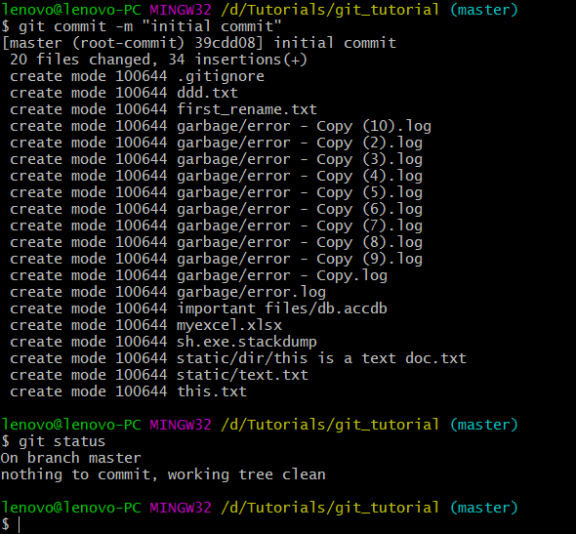

🡪

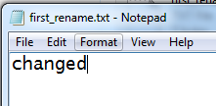

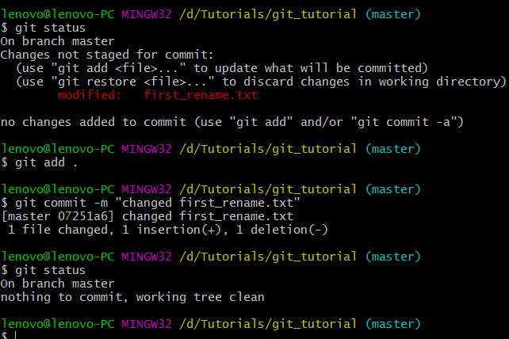

🡪

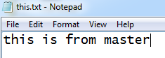 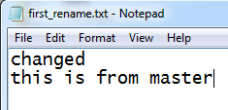

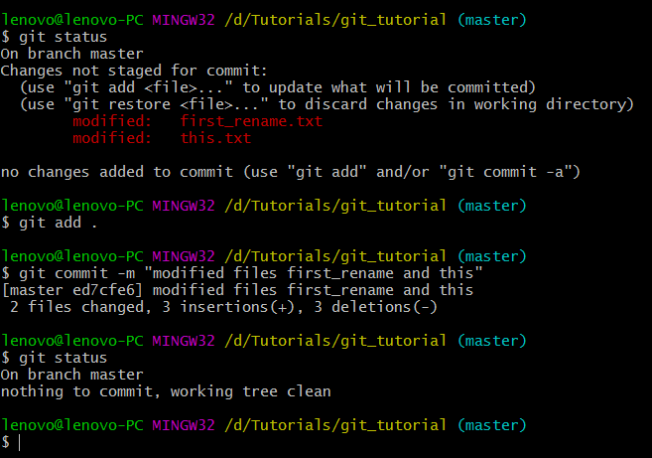

🡪

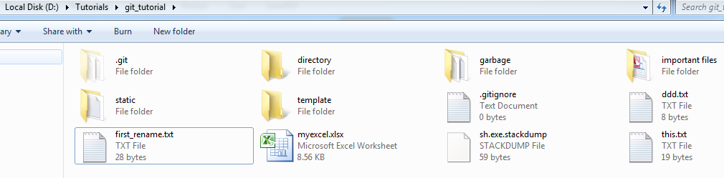

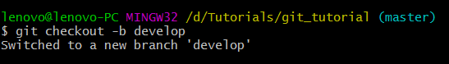

🡪we are in develop branch now. I’ve deleted some files. See below:

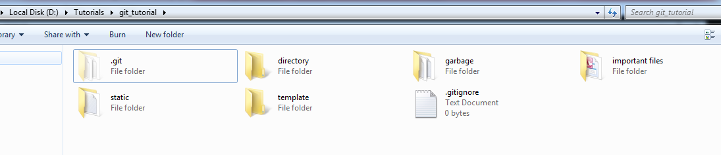

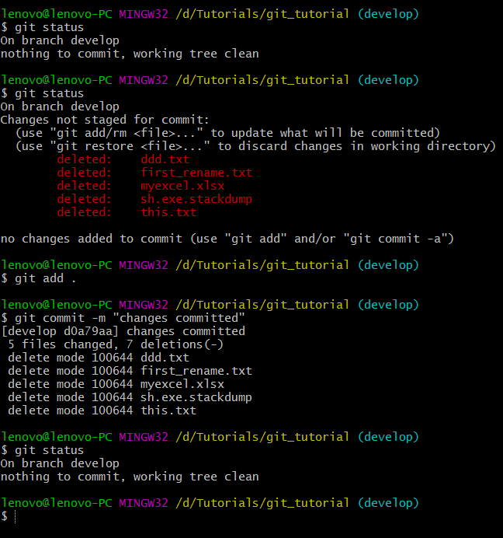

🡪

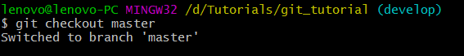

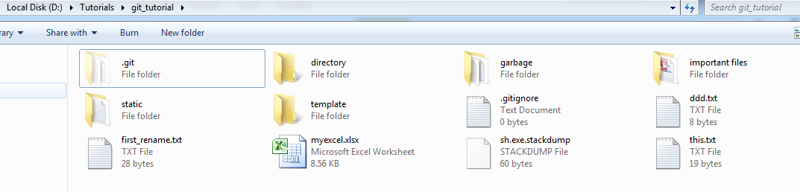

🡪 **$ git branch**

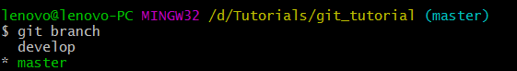

**☺16 Branching - Merging a Production Grade Project**



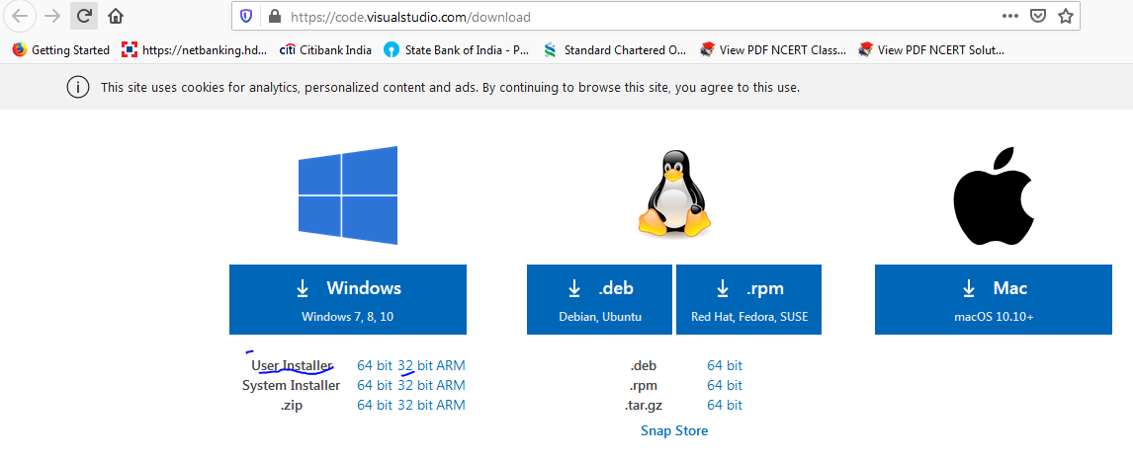

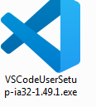

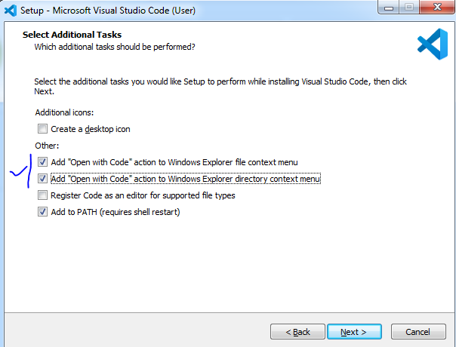

🡪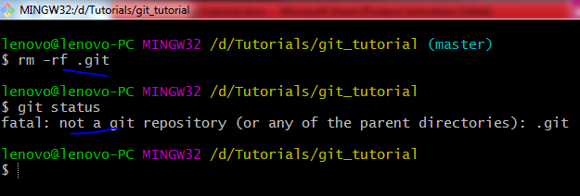

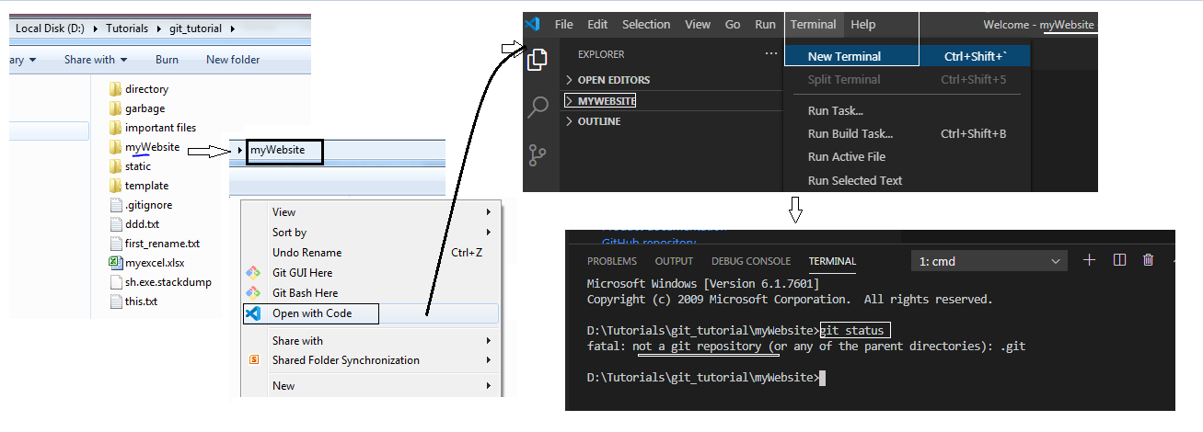

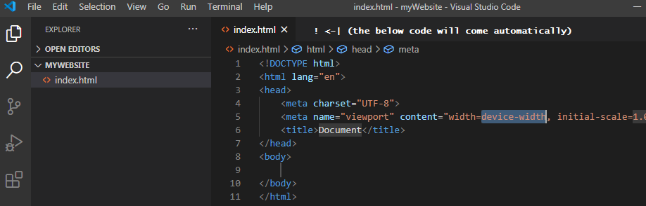



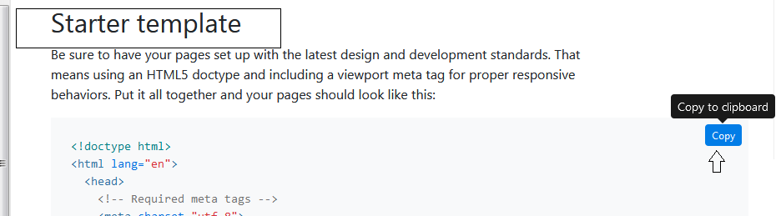

Paste it in vs

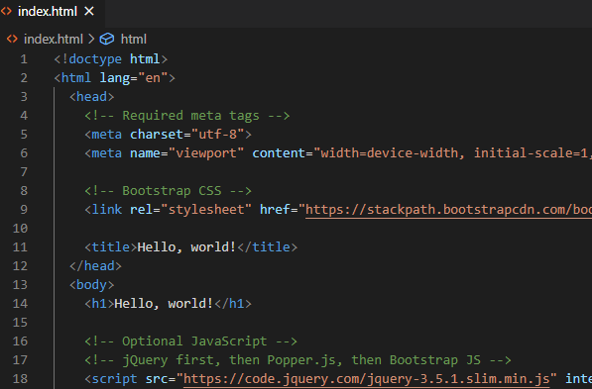

Install live server extension

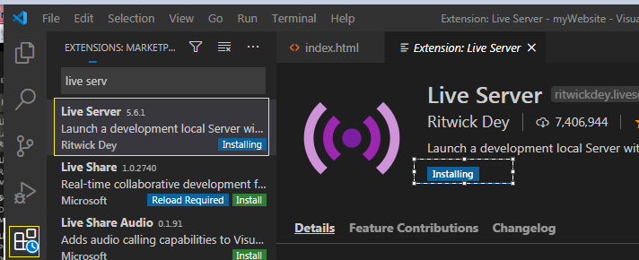

After installation you’ll find **Go live** in the bottom

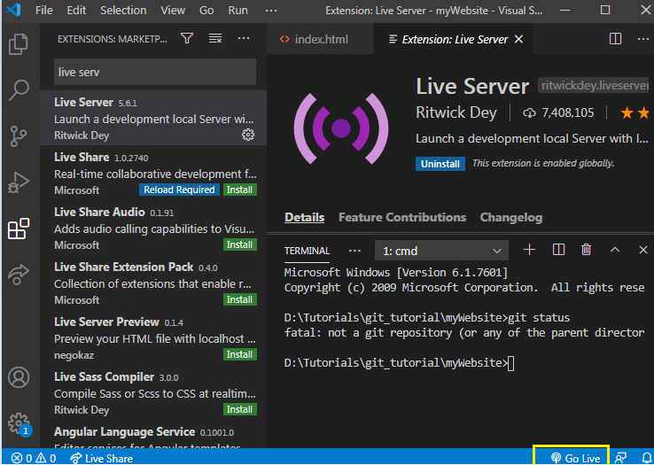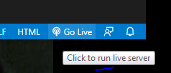 now your page will open in browser.

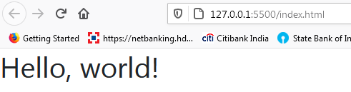

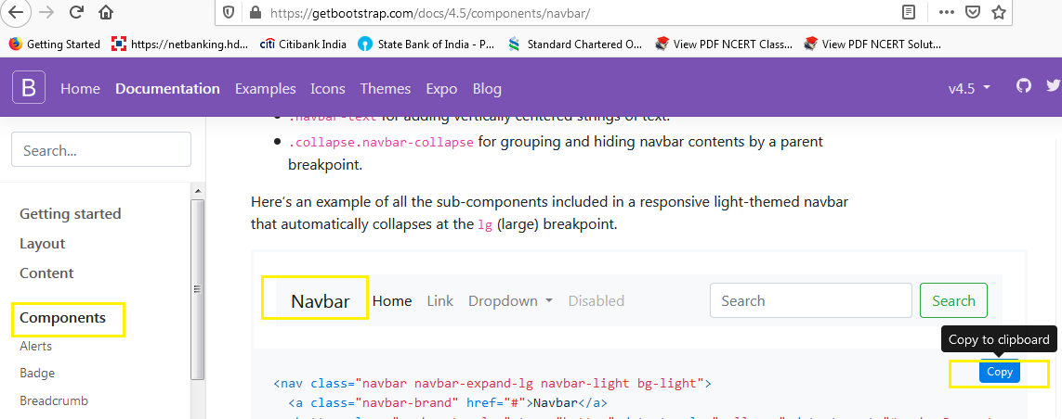

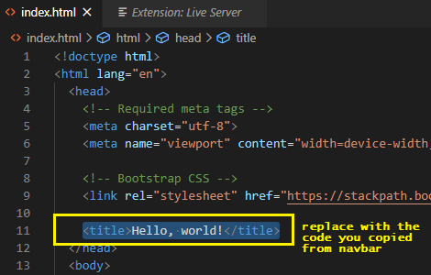

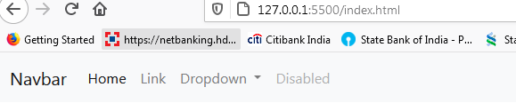

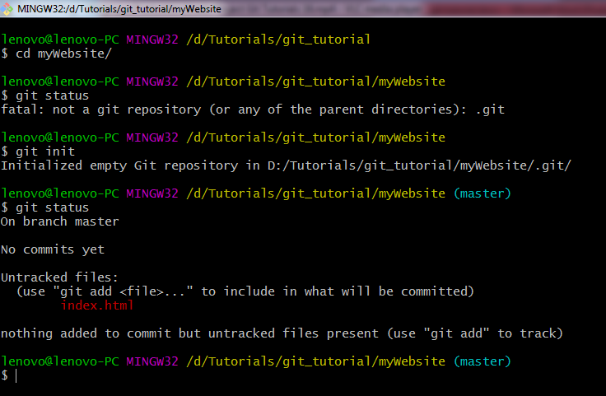

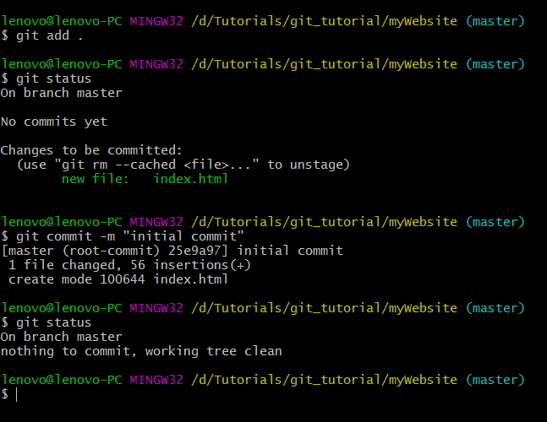

Suppose the initial commit code is up and running in production. So, we don’t want to mess with that. Hence we will create a new branch where we will enhanced the features

🡪Now we will do our changes

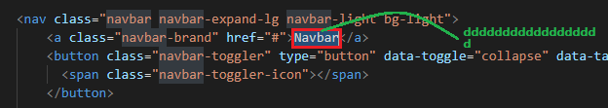

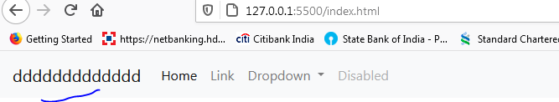

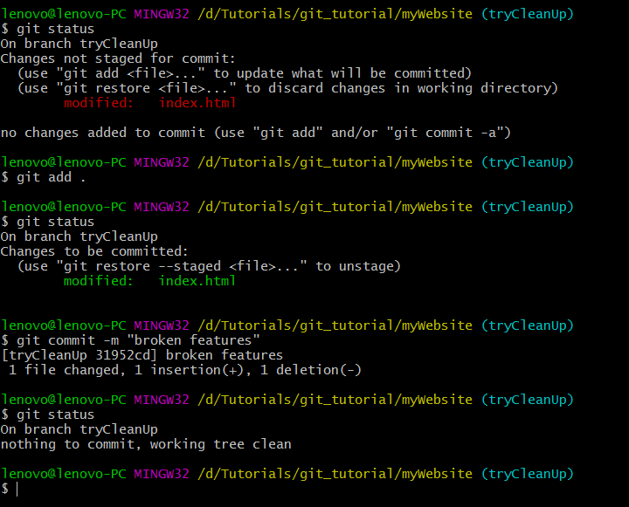

Going back to the previous stage

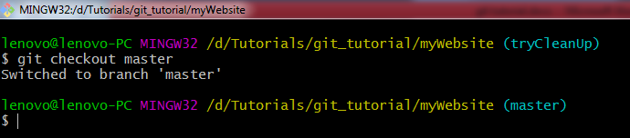

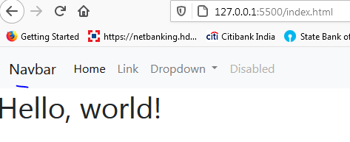

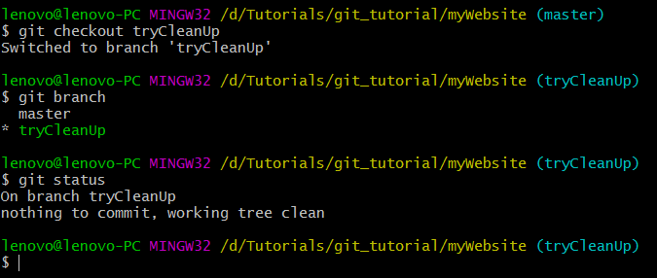

Do changes in the code in tryCleanUp branch

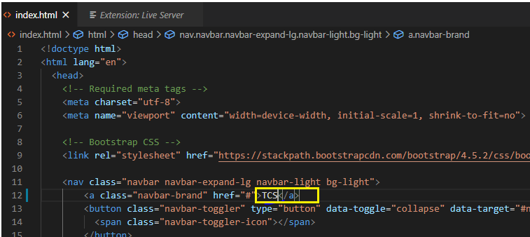

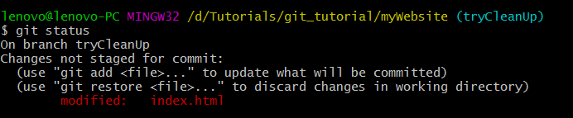

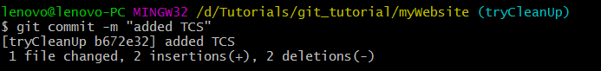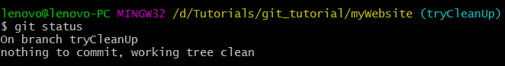

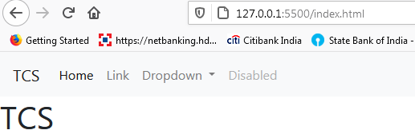

Now we will merge our changes from tryCleanUp branch to master branch. So that our modification can go live in the production environment

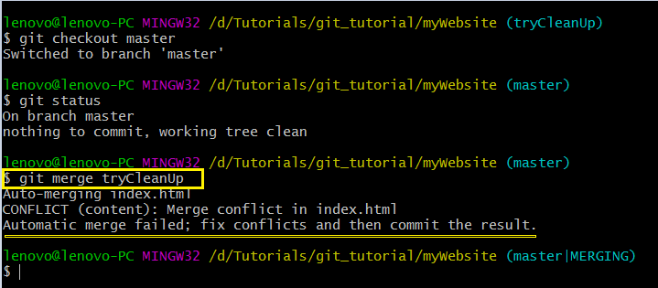

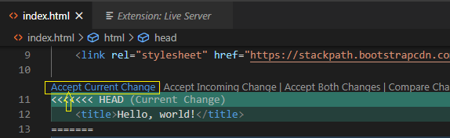

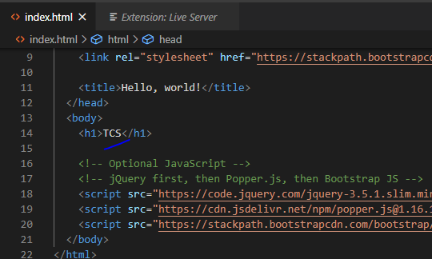

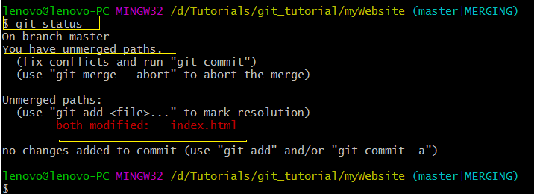

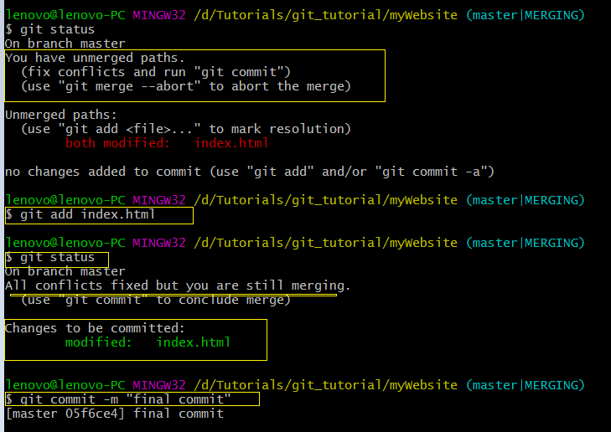

**☺17 Resolving Merge Conflicts -With Example**

Q. what is merge conflict?  
-> The conflict which arises when we are merging a branch and GIT is not able to merge it because of the conflict in the code between branches

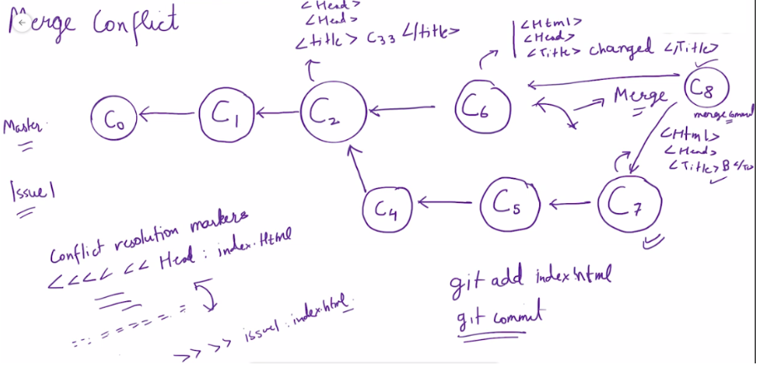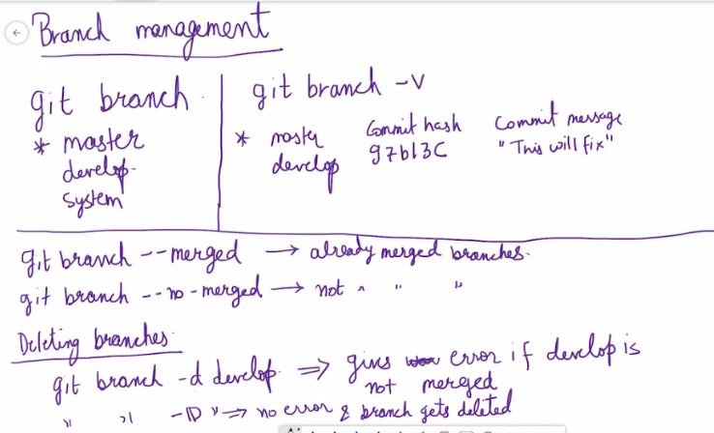

🡪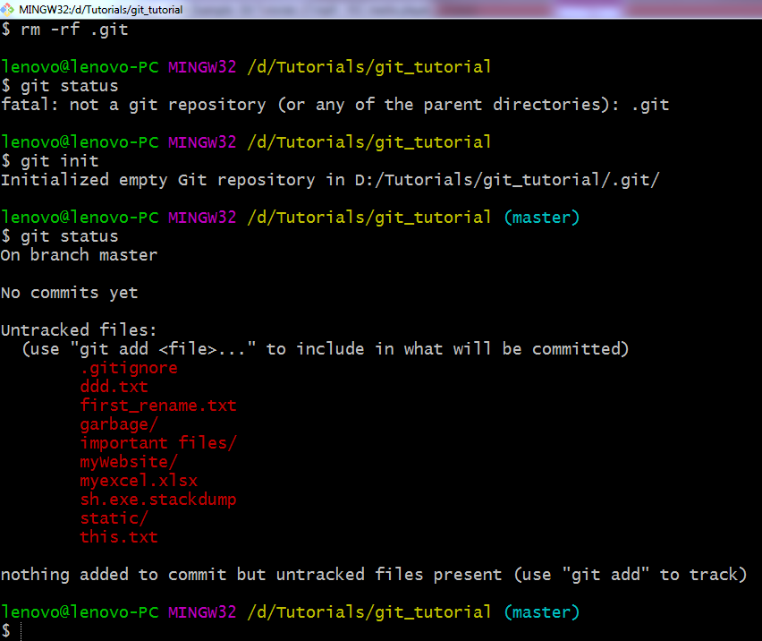

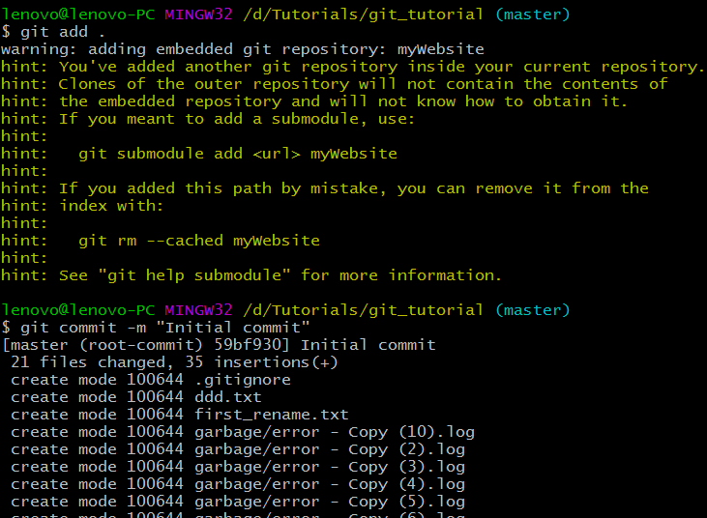

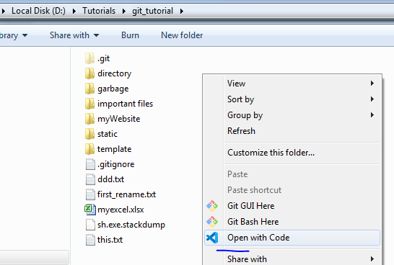

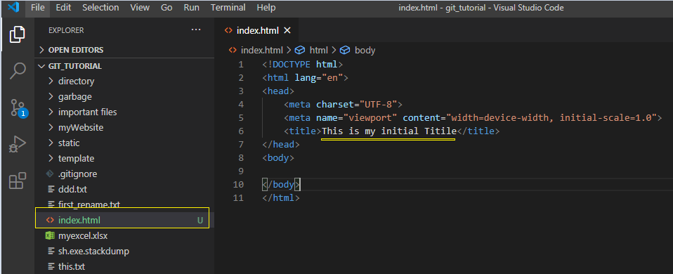

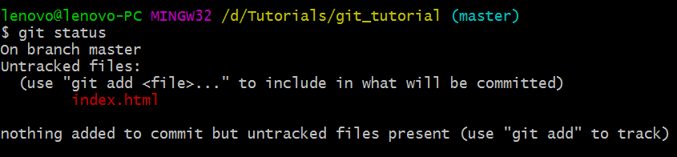

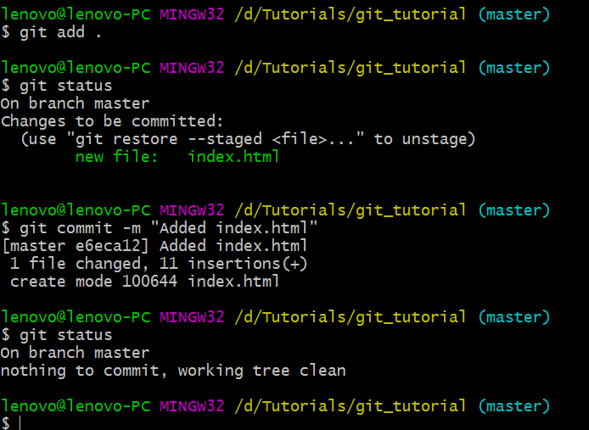🡪

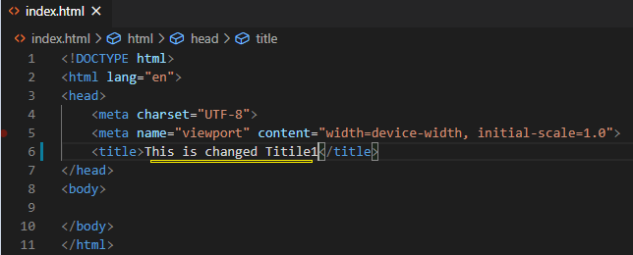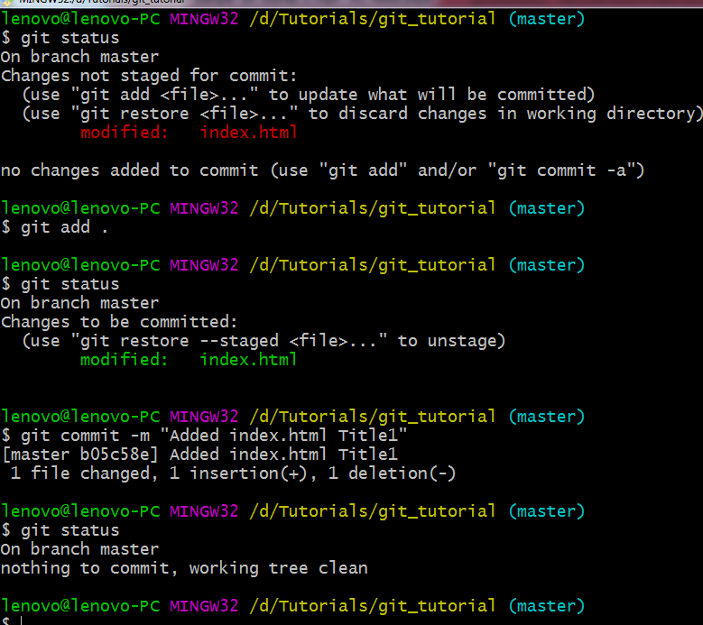

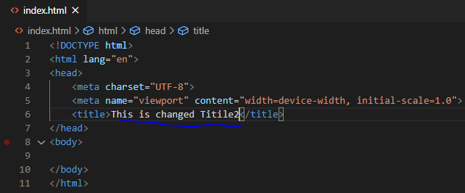

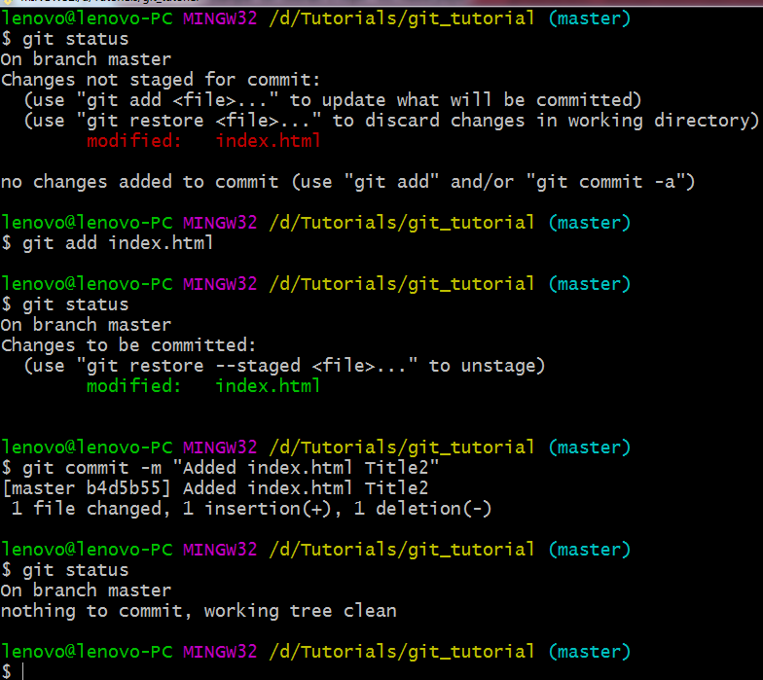

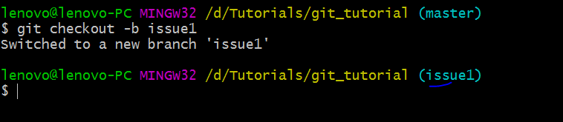

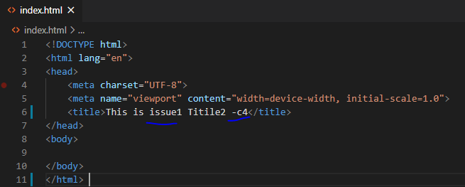

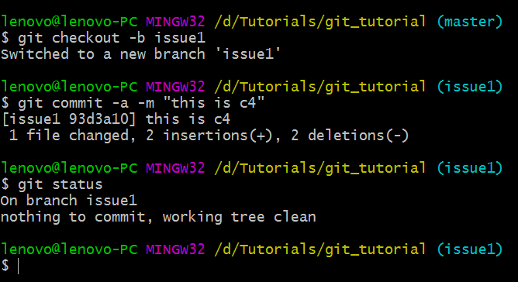

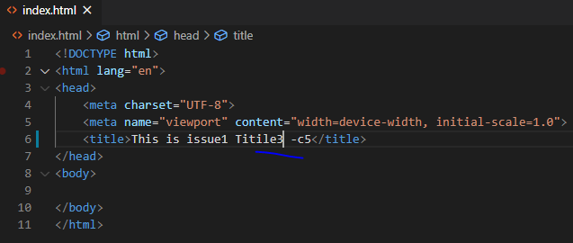

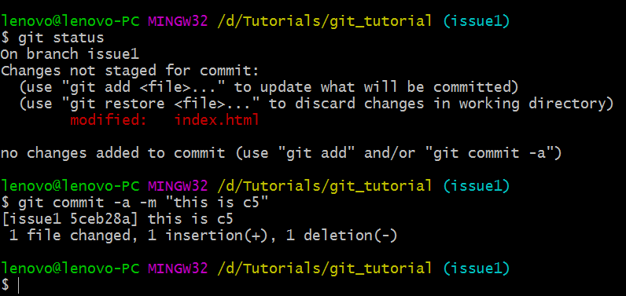

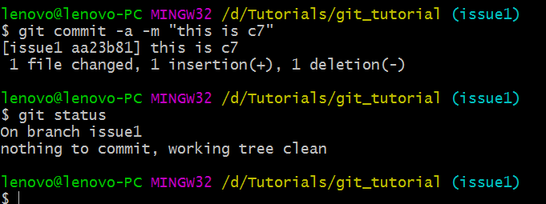

Now change the branch

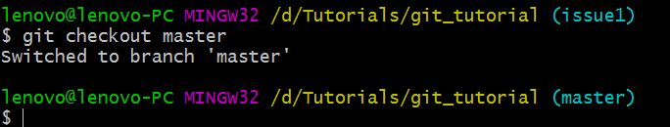

We have come to the last state of master branch

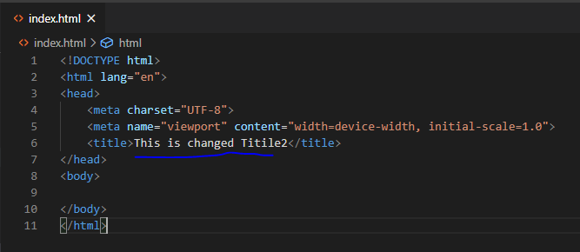

🡪

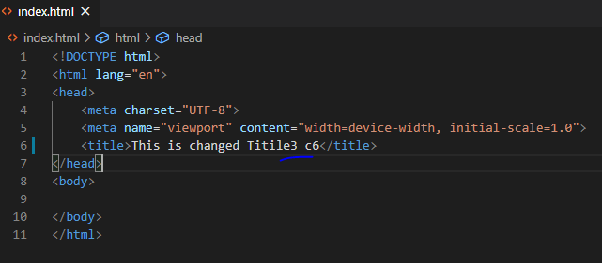

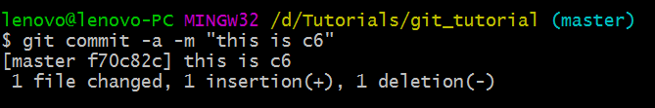

🡪

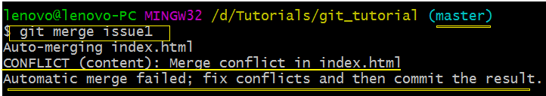

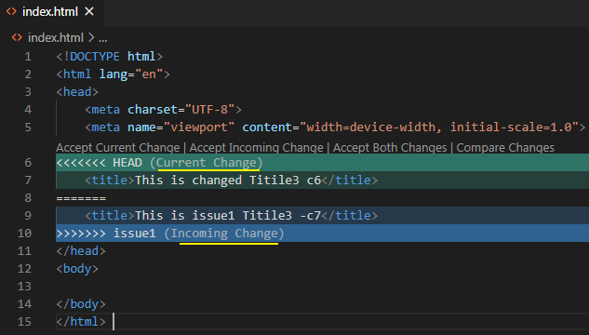

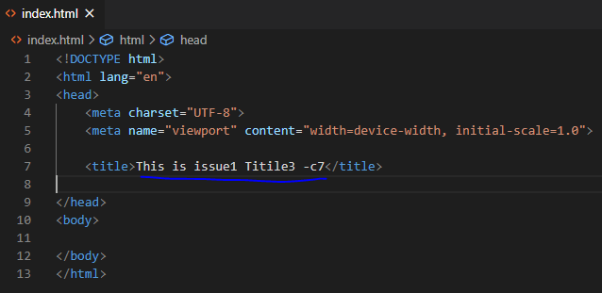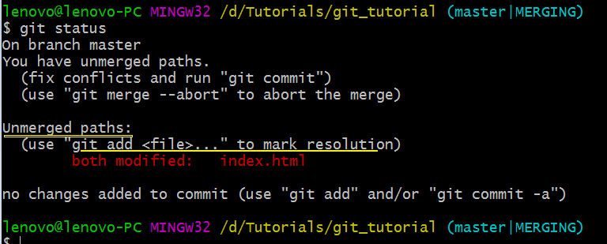

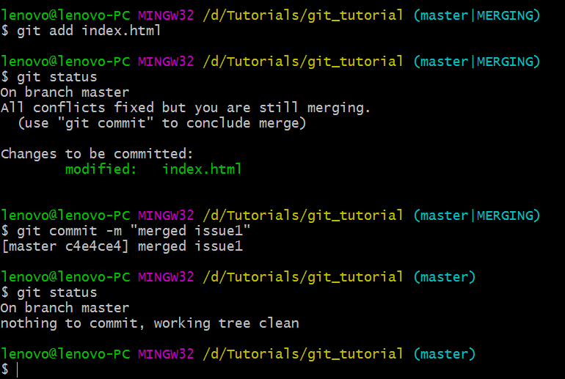

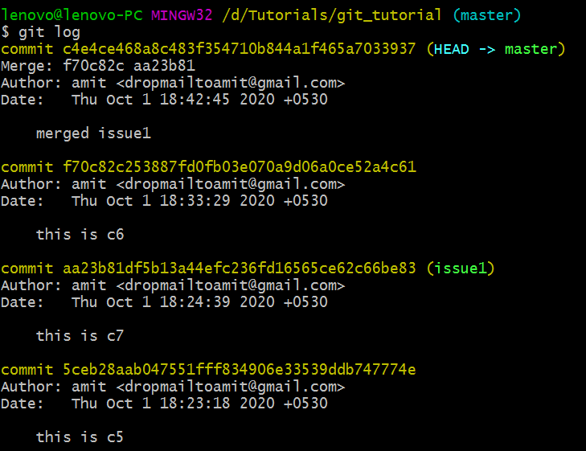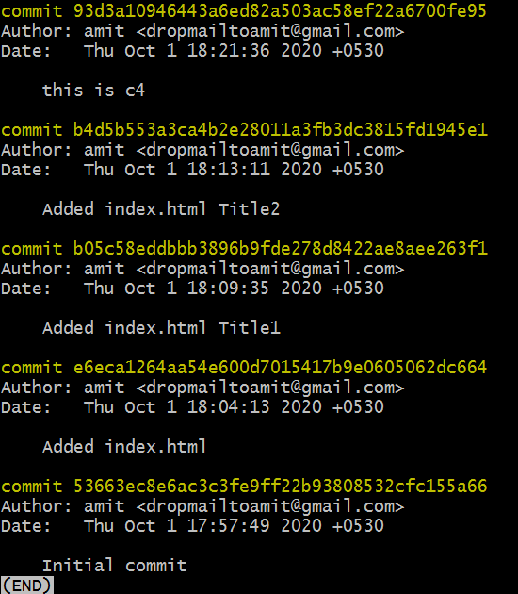

🡪We created a branch and did some mistake

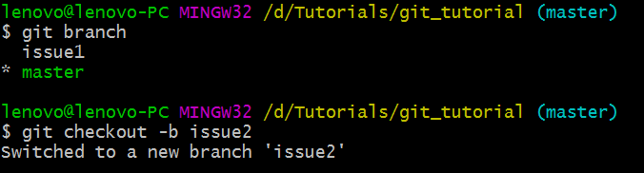

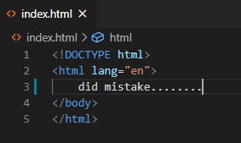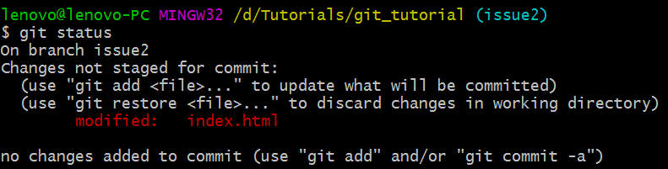

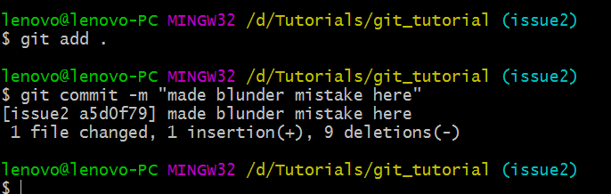

🡪

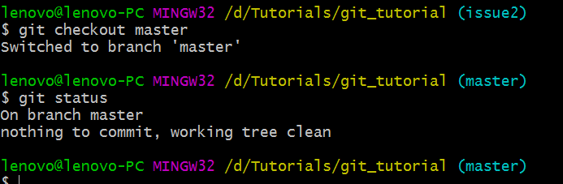

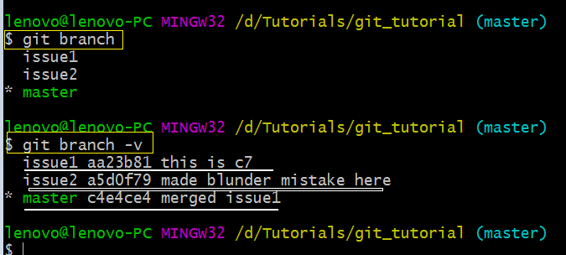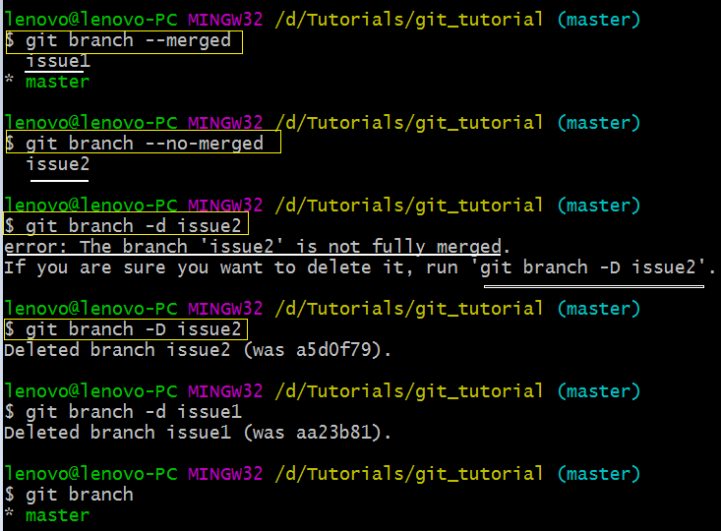

**☺19 Pushing Git Branches To Remote Repositories**

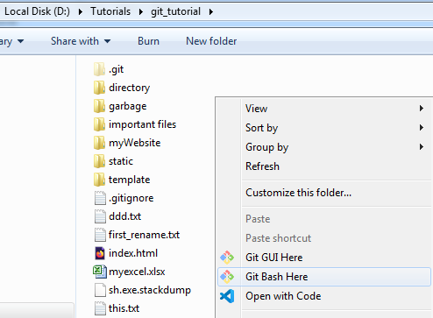

🡪

lenovo@lenovo-PC MINGW32 /d/Tutorials/git_tutorial

$ git status

fatal: not a git repository (or any of the parent directories): .git

lenovo@lenovo-PC MINGW32 /d/Tutorials/git_tutorial

$ git init

Initialized empty Git repository in D:/Tutorials/git_tutorial/.git/

lenovo@lenovo-PC MINGW32 /d/Tutorials/git_tutorial (master)

$ git status

On branch master

No commits yet

Untracked files:

(use "git add <file>..." to include in what will be committed)

.gitignore

ddd.txt

first_rename.txt

garbage/

important files/

index.html

myWebsite/

sh.exe.stackdump

static/

this.txt

nothing added to commit but untracked files present (use "git add" to track)

lenovo@lenovo-PC MINGW32 /d/Tutorials/git_tutorial (master)

$ git add .

warning: adding embedded git repository: myWebsite

hint: You've added another git repository inside your current repository.

hint: Clones of the outer repository will not contain the contents of

hint: the embedded repository and will not know how to obtain it.

hint: If you meant to add a submodule, use:

hint:

hint: git submodule add <url> myWebsite

hint:

hint: If you added this path by mistake, you can remove it from the

hint: index with:

hint:

hint: git rm --cached myWebsite

hint:

hint: See "git help submodule" for more information.

lenovo@lenovo-PC MINGW32 /d/Tutorials/git_tutorial (master)

$ git commit -m "initial commit"

[master (root-commit) c74a6f8] initial commit

21 files changed, 47 insertions(+)

create mode 100644 .gitignore

create mode 100644 ddd.txt

create mode 100644 first_rename.txt

create mode 100644 garbage/error - Copy (10).log

create mode 100644 garbage/error - Copy (2).log

create mode 100644 garbage/error - Copy (3).log

create mode 100644 garbage/error - Copy (4).log

create mode 100644 garbage/error - Copy (5).log

create mode 100644 garbage/error - Copy (6).log

create mode 100644 garbage/error - Copy (7).log

create mode 100644 garbage/error - Copy (8).log

create mode 100644 garbage/error - Copy (9).log

create mode 100644 garbage/error - Copy.log

create mode 100644 garbage/error.log

create mode 100644 important files/db.accdb

create mode 100644 index.html

create mode 160000 myWebsite

create mode 100644 sh.exe.stackdump

create mode 100644 static/dir/this is a text doc.txt

create mode 100644 static/text.txt

create mode 100644 this.txt

lenovo@lenovo-PC MINGW32 /d/Tutorials/git_tutorial (master)

$ git status

On branch master

nothing to commit, working tree clean

lenovo@lenovo-PC MINGW32 /d/Tutorials/git_tutorial (master)

$

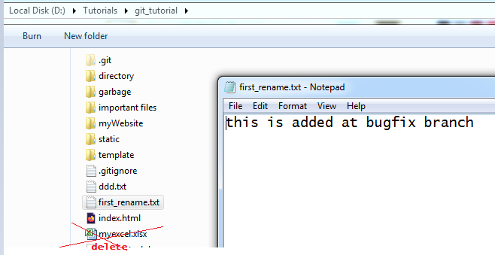

lenovo@lenovo-PC MINGW32 /d/Tutorials/git_tutorial (master)

$ git log

commit c74a6f8e78eb3f10cdf74a4fa1109761023ba191 (HEAD -> master)

Author: amit <dropmailtoamit@gmail.com>

Date: Fri Oct 2 07:57:47 2020 +0530

initial commit

lenovo@lenovo-PC MINGW32 /d/Tutorials/git_tutorial (master)

$ git branch

* master

lenovo@lenovo-PC MINGW32 /d/Tutorials/git_tutorial (master)

$ git checkout -b bugfix

Switched to a new branch 'bugfix'

lenovo@lenovo-PC MINGW32 /d/Tutorials/git_tutorial (bugfix)

$ git status

On branch bugfix

nothing to commit, working tree clean

lenovo@lenovo-PC MINGW32 /d/Tutorials/git_tutorial (bugfix)

$ git branch

* bugfix

master

lenovo@lenovo-PC MINGW32 /d/Tutorials/git_tutorial (bugfix)

$ git log

commit c74a6f8e78eb3f10cdf74a4fa1109761023ba191 (HEAD -> bugfix, master)

Author: amit <dropmailtoamit@gmail.com>

Date: Fri Oct 2 07:57:47 2020 +0530

initial commit

lenovo@lenovo-PC MINGW32 /d/Tutorials/git_tutorial (bugfix)

$ git status

On branch bugfix

Changes not staged for commit:

(use "git add <file>..." to update what will be committed)

(use "git restore <file>..." to discard changes in working directory)

modified: first_rename.txt

no changes added to commit (use "git add" and/or "git commit -a")

lenovo@lenovo-PC MINGW32 /d/Tutorials/git_tutorial (bugfix)

$ git status

On branch bugfix

Changes not staged for commit:

(use "git add <file>..." to update what will be committed)

(use "git restore <file>..." to discard changes in working directory)

modified: first_rename.txt

no changes added to commit (use "git add" and/or "git commit -a")

lenovo@lenovo-PC MINGW32 /d/Tutorials/git_tutorial (bugfix)

$ git add .

lenovo@lenovo-PC MINGW32 /d/Tutorials/git_tutorial (bugfix)

$ git commit -m "Fixed the bug"

[bugfix 4d97a91] Fixed the bug

1 file changed, 2 insertions(+), 1 deletion(-)

lenovo@lenovo-PC MINGW32 /d/Tutorials/git_tutorial (bugfix)

$ git status

On branch bugfix

nothing to commit, working tree clean

lenovo@lenovo-PC MINGW32 /d/Tutorials/git_tutorial (bugfix)

$ git checkout master

Switched to branch 'master'

lenovo@lenovo-PC MINGW32 /d/Tutorials/git_tutorial (master)

$ git branch

bugfix

* master

lenovo@lenovo-PC MINGW32 /d/Tutorials/git_tutorial (master)

**$ git remote (we don’t have any remote set up which is why we are getting nothing when**

**we run this command)**

lenovo@lenovo-PC MINGW32 /d/Tutorials/git_tutorial (master)

**$ git remote –v**

**🡪** Now we will set up the remote by creating the repository in GITHUB.

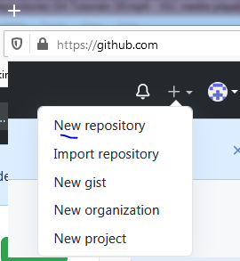

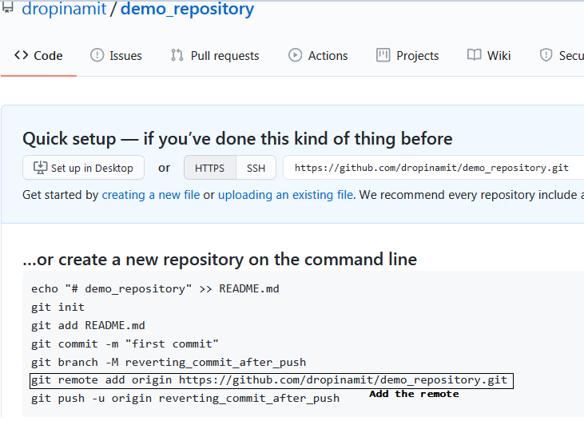

lenovo@lenovo-PC MINGW32 /d/Tutorials/git_tutorial (bugfix)

$ git checkout master

Switched to branch 'master'

lenovo@lenovo-PC MINGW32 /d/Tutorials/git_tutorial (master)

$ git branch

bugfix

* master

lenovo@lenovo-PC MINGW32 /d/Tutorials/git_tutorial (master)

$ git remote

lenovo@lenovo-PC MINGW32 /d/Tutorials/git_tutorial (master)

$ git remote -v

lenovo@lenovo-PC MINGW32 /d/Tutorials/git_tutorial (master)

$ git remote add origin https://github.com/dropinamit/demo_repository.git

lenovo@lenovo-PC MINGW32 /d/Tutorials/git_tutorial (master)

$ git remote -v

origin https://github.com/dropinamit/demo_repository.git (fetch)

origin https://github.com/dropinamit/demo_repository.git (push)

lenovo@lenovo-PC MINGW32 /d/Tutorials/git_tutorial (master)

$ git remote

origin

lenovo@lenovo-PC MINGW32 /d/Tutorials/git_tutorial (master)

$

🡪Now we will push our code in master branch in GITHUB

lenovo@lenovo-PC MINGW32 /d/Tutorials/git_tutorial (master)

$ git push -u origin master

Enumerating objects: 17, done.

Counting objects: 100% (17/17), done.

Delta compression using up to 4 threads

Compressing objects: 100% (9/9), done.

Writing objects: 100% (17/17), 20.77 KiB | 1.38 MiB/s, done.

Total 17 (delta 0), reused 0 (delta 0), pack-reused 0

To https://github.com/dropinamit/demo_repository.git

* [new branch] master -> master

Branch 'master' set up to track remote branch 'master' from 'origin'.

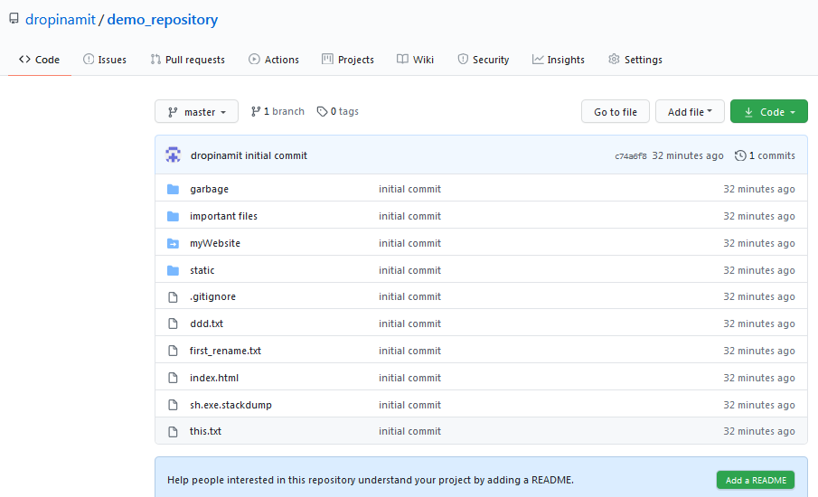

🡪We have to publish our branch (bugfix) to remote

lenovo@lenovo-PC MINGW32 /d/Tutorials/git_tutorial (master)

$ git branch

bugfix

* master

lenovo@lenovo-PC MINGW32 /d/Tutorials/git_tutorial (master)

$ git status

On branch master

Your branch is up to date with 'origin/master'.

nothing to commit, working tree clean

lenovo@lenovo-PC MINGW32 /d/Tutorials/git_tutorial (master)

$ git status

On branch master

Your branch is up to date with 'origin/master'.

nothing to commit, working tree clean

lenovo@lenovo-PC MINGW32 /d/Tutorials/git_tutorial (master)

$ git checkout bugfix

Switched to branch 'bugfix'

lenovo@lenovo-PC MINGW32 /d/Tutorials/git_tutorial (bugfix)

$ git checkout master

Switched to branch 'master'

Your branch is up to date with 'origin/master'.

lenovo@lenovo-PC MINGW32 /d/Tutorials/git_tutorial (master)

$ git push origin bugfix

Enumerating objects: 5, done.

Counting objects: 100% (5/5), done.

Delta compression using up to 4 threads

Compressing objects: 100% (3/3), done.

Writing objects: 100% (3/3), 302 bytes | 302.00 KiB/s, done.

Total 3 (delta 1), reused 0 (delta 0), pack-reused 0

remote: Resolving deltas: 100% (1/1), completed with 1 local object.

remote:

remote: Create a pull request for 'bugfix' on GitHub by visiting:

remote: https://github.com/dropinamit/demo_repository/pull/new/bugfix

remote:

To https://github.com/dropinamit/demo_repository.git

* [new branch] **bugfix -> bugfix**

lenovo@lenovo-PC MINGW32 /d/Tutorials/git_tutorial (master)

$

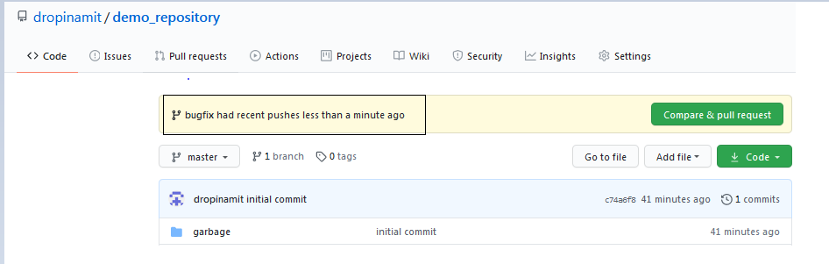 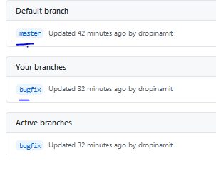

lenovo@lenovo-PC MINGW32 /d/Tutorials/git_tutorial (master)

$ git checkout bugfix

Switched to branch 'bugfix'

lenovo@lenovo-PC MINGW32 /d/Tutorials/git_tutorial (bugfix)

$ git push origin bugfix:mybugfix

Total 0 (delta 0), reused 0 (delta 0), pack-reused 0

remote:

remote: Create a pull request for 'mybugfix' on GitHub by visiting:

remote: https://github.com/dropinamit/demo_repository/pull/new/mybugfix

remote:

To https://github.com/dropinamit/demo_repository.git

* [new branch] bugfix -> mybugfix

lenovo@lenovo-PC MINGW32 /d/Tutorials/git_tutorial (bugfix)

$ git status

On branch bugfix

nothing to commit, working tree clean

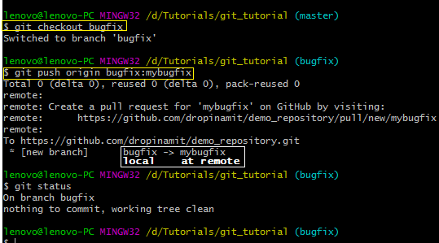

**$ git push origin bugfix:mybugfix**

**The name in the local is bugfix and in remote(i.e. github) branch name is mybugfix**

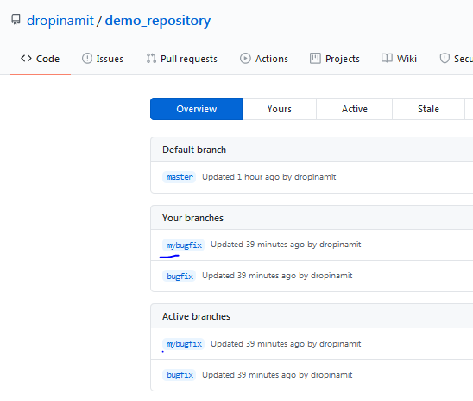

lenovo@lenovo-PC MINGW32 /d/Tutorials/git_tutorial (bugfix)

$ git checkout master

Switched to branch 'master'

Your branch is up to date with 'origin/master'.

lenovo@lenovo-PC MINGW32 /d/Tutorials/git_tutorial (master)

$ git branch

bugfix

* master

lenovo@lenovo-PC MINGW32 /d/Tutorials/git_tutorial (master)

$ git branch -d bugfix

error: The branch 'bugfix' is not fully merged.

If you are sure you want to delete it, run 'git branch -D bugfix'.

lenovo@lenovo-PC MINGW32 /d/Tutorials/git_tutorial (master)

$

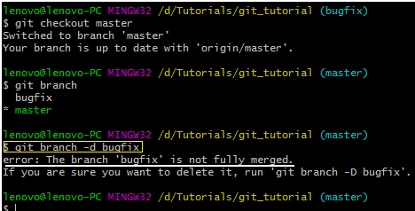

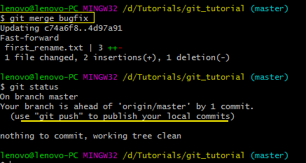

Q. will the below command will delete the bugfix branch

lenovo@lenovo-PC MINGW32 /d/Tutorials/git_tutorial (master)

**$ git branch -d bugfix**

lenovo@lenovo-PC MINGW32 /d/Tutorials/git_tutorial (master)

$ git branch -d bugfix

Deleted branch bugfix (was 4d97a91).

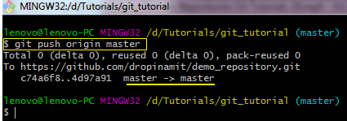

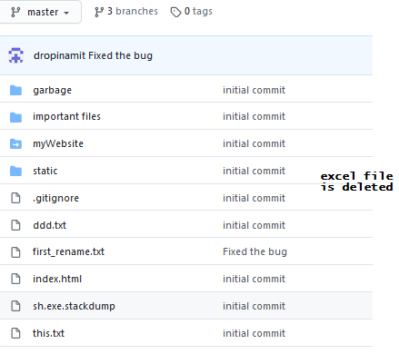

🡪Deleting branches in remote

lenovo@lenovo-PC MINGW32 /d/Tutorials/git_tutorial (master)

**$ git push -d origin bugfix**

To https://github.com/dropinamit/demo_repository.git

- [deleted] bugfix

